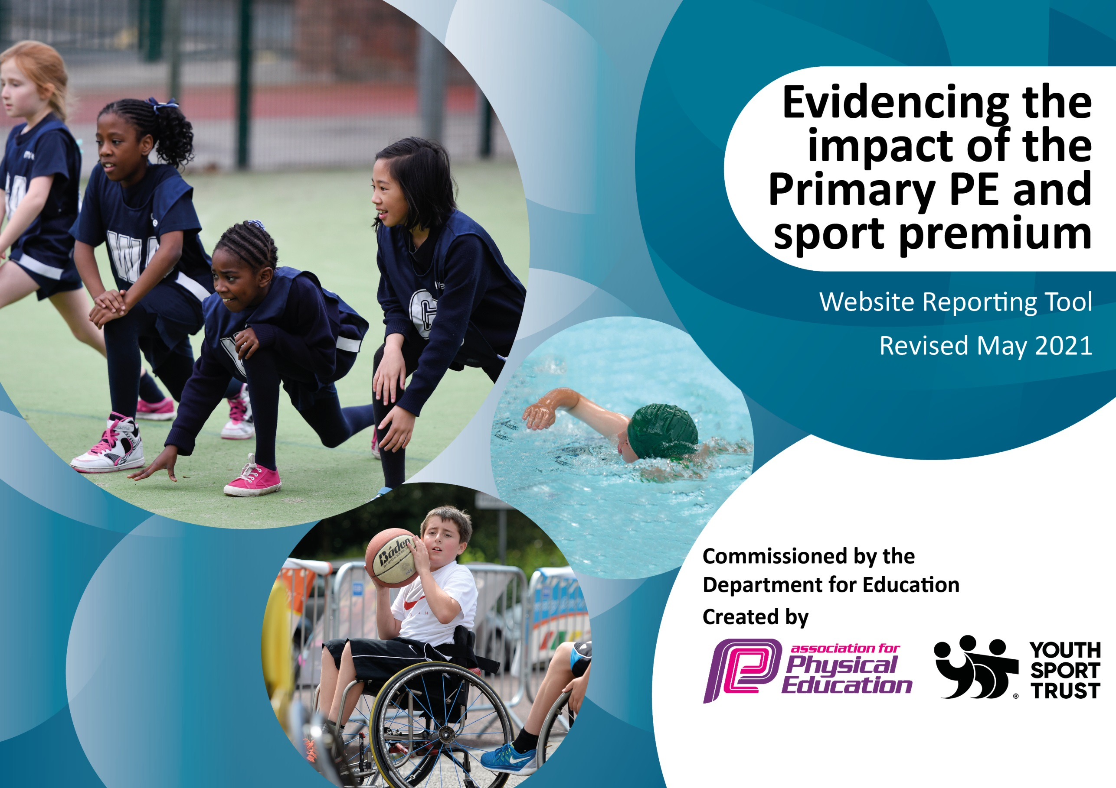

It is important that your grant is used effectively and based on school need. The Education Inspection Framework (Ofsted 2019 p64) makes clear there will be a focus on ‘whether leaders and those responsible for governors all understand their respective roles and perform these in a way that enhances the effectiveness of the school’.

Under the Quality of Education criteria (p41) inspectors consider the extent to which schools can articulate their curriculum (INTENT), construct their curriculum (IMPLEMENTATION) and demonstrate the outcomes which result (IMPACT).

To assist schools with common transferable language this template has been developed to utilise the same three headings which should make your plans easily transferable between working documents.

Schools must use the funding to make additional and sustainable improvements to the quality of Physical Education, School Sport and Physical Activity (PESSPA) they offer. This means that you should use the Primary PE and sport premium to:

- Develop or add to the PESSPA activities that your school already offer
- Build capacity and capability within the school to ensure that improvements made now will benefit pupils joining the school in future years
- The Primary PE and sport premium should not be used to fund capital spend projects; the school’s budget should fund these.
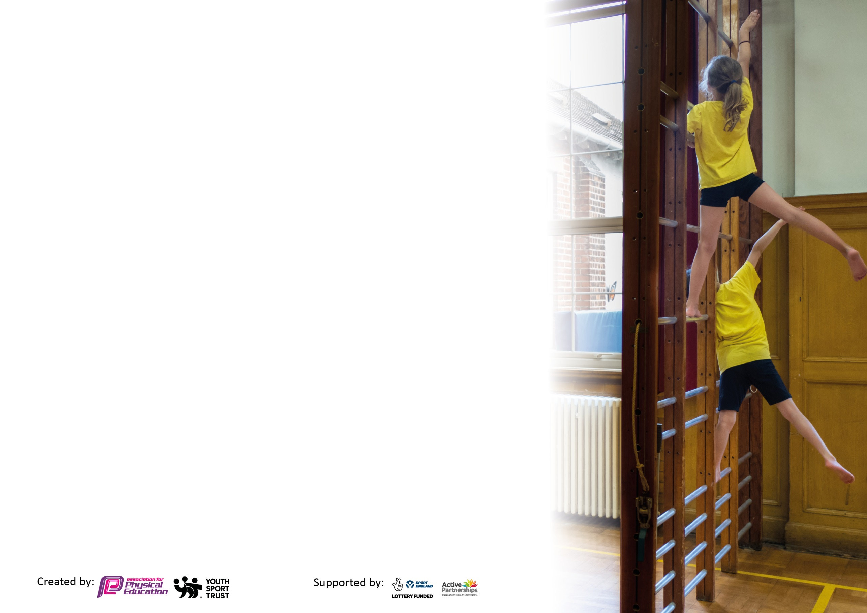
Please visit gov.uk for the revised DfE guidance including the 5 key indicators across which schools should demonstrate an improvement. This document will help you to review your provision and to report your spend. DfE encourages schools to use this template as an effective way of meeting the reporting requirements of the Primary PE and sport premium.

We recommend you start by reflecting on the impact of current provision and reviewing the previous spend.

Schools are required to publish details of how they spend this funding, including any under-spend from 2019/2020, as well as on the impact it has on pupils’ PE and sport participation and attainment by the end of the summer term or by 31st July 2021 at the latest.

We recommend regularly updating the table and publishing it on your website throughout the year. This evidences your ongoing self-evaluation of how you are using the funding to secure maximum, sustainable impact. Final copy must be posted on your website by the end of the academic year and no later than the 31st July 2021. To see an example of how to complete the table please click HERE.



Support for review and reflection - considering the 5 key indicators from DfE, what development needs are a priority for your setting and your pupils now and why? Use the space below to reflect on previous spend and key achievements and areas for development.

Key achievements to date until July 2024: | Areas for further improvement and baseline evidence of need:
- High quality teaching of PE – Purchased Get Set 4 PE Scheme  - purchased high quality PE equipment  - New daily mile track to increase participation in physical activity across whole school  - Wide range of sports provided (e.g. NFL after-school club)  - New outdoor learning areas to promote active and outdoor learning  - Purchase of ‘Teach Active’ to increase ‘active learning’ throughout school  - Play leaders and new playtime equipment  - High quality coaches to increase staff confidence and deliver high-quality PE lessons in relation to Staff questionnaire feedback and to provide staff CPD on gymnastics & dance  - Participation in more competitions, including girls only competitions and level 2 and 3 competition opportunities  - Cross-curricular orienteering course and resources purchased  - Additional outdoor play equipment for infants to encourage physical activity  - More competitions for SEND and infants as per last years target | - To host more competitions at our school  - To have more intra-school competitions  - To provide more opportunities for GDS pupils to excel

Did you carry forward an underspend from 2019-20 academic year into the current academic year? YES
Total amount carried forward from 2022/23 £0
+ Total amount for this academic year 2023/2024 £17,970
= Total to be spent by 31st July 2024 £17,970
Meeting national curriculum requirements for swimming and water safety.

N.B Complete this section to your best ability. For example you might have practised safe self-rescue techniques on dry land which you can transfer to the pool when school swimming restarts.
Due to exceptional circumstances priority should be given to ensuring that pupils can perform safe self rescue even
if they do not fully meet the first two requirements of the NC programme of study.
What percentage of your current Year 6 cohort swim competently, confidently and proficiently over a distance of at least 25 metres?  N.B. Even though your pupils may swim in another year please report on their attainment on leaving primary school at the end of the summer term 2021.  Please see note above. | 77%
What percentage of your current Year 6 cohort use a range of strokes effectively [for example, front crawl, backstroke and breaststroke]?  Please see note above. | 77%
What percentage of your current Year 6 cohort perform safe self-rescue in different water-based situations? | 81%
Schools can choose to use the Primary PE and sport premium to provide additional provision for swimming but this must be for activity over and above the national curriculum requirements. Have you used it in this way? | Yes

Action Plan and Budget Tracking
Capture your intended annual spend against the 5 key indicators. Clarify the success criteria and evidence of impact that you intend to measure to evaluate for pupils today and for the future.

Academic Year: 2022/23 | Total fund allocated: £19,450 | Date Updated: July 2023
Key indicator 1: The engagement of all pupils in regular physical activity – Chief Medical Officers guidelines recommend that primary school pupils undertake at least 30 minutes of physical activity a day in school |  |  |  | Percentage of total allocation:
 |  |  |  | 30%
Intent | Implementation |  | Impact
Your school focus should be clear what you want the pupils to know and be able to do and about  what they need to learn and to  consolidate through practice: | Make sure your actions to achieve are linked to your intentions: | Funding allocated: | Evidence of impact: what do pupils now know and what can they now do? What has changed?: | Sustainability and suggested next steps:
Increase cycling awareness and proficiency in juniors  For all children to be able to swim 25 metres when leaving year 6.  Staff courses EYFS/ Active Learning /Forest schools/ Outdoor learning/ PE coordinators conference | Pedal and Scoot cycling day  High quality teaching of regular swimming lessons for UKS2 pupils during summer term  Staff confidence and competence improves to provide high-quality lessons and provision | £200  £3140  £2000 | Increase road safety (linked to school value of safety) when cycling and encourage active travel to school.  Improved pupil confidence and competence in swimming and water safety by the end of KS2  Pupils make stronger progress and become more well-rounded sports people | To be continued annually  Year 4/5/6 yearly  Continue to keep staff training present and relevant
Key indicator 2: The profile of PESSPA being raised across the school as a tool for whole school improvement |  |  |  | Percentage of total allocation:
 |  |  |  | 16%
Intent | Implementation |  | Impact
Your school focus should be clear what you want the pupils to know and be able to do and about  what they need to learn and to  consolidate through practice: | Make sure your actions to achieve are linked to your intentions: | Funding allocated: | Evidence of impact: what do pupils now know and what can they now do? What has changed?: | Sustainability and suggested next steps:
Encourage and promote more opportunities and engagement in PESSPA - especially SEND and Girls  To provide high-quality PE lessons across the school in a wide variety of sports (e.g. forest school/outdoor learning) | School Games Values promoted throughout the year (within PE lessons and inter-school competitions) including informing parents and providing certificates to children  New, high-quality PE equipment purchased and outdoor learning resources to maximise achievement of ELGs for Physical Development (gross and fine motor skills) | £0  £2885 | Children understand the importance of PESSPA and given opportunities to succeed, take part and develop through sport.  Teachers can teach the GS4PE curriculum effectively and to a high standard, to provide children with the best possible experience of PE throughout primary school.  EYFS staff has resources, equipment and outdoor/active areas to provide opportunities for achieving ELGs | Continue to implement  Post regular updates on school social media platforms/ blogs  Ensure PE equipment is always monitored and updated as required inline with the school curriculum.

Key indicator 3: Increased confidence, knowledge and skills of all staff in teaching PE and sport |  |  |  | Percentage of total allocation:
 |  |  |  | 3%
Intent | Implementation |  | Impact
Your school focus should be clear | Make sure your actions to | Funding | Evidence of impact: what do | Sustainability and suggested
what you want the pupils to know | achieve are linked to your | allocated: | pupils now know and what | next steps:
and be able to do and about | intentions: |  | can they now do? What has
what they need to learn and to |  |  | changed?:
consolidate through practice:
High quality teaching of PE across the whole school  Improving staff knowledge on implementing active learning within the classroom | Get Set 4 PE planning and assessment scheme purchased for whole school use.  Active Learning CPD session for staff | £550  £0 | Improved confidence and competence for all teaching staff to deliver high quality PE lessons.  Improved confidence and competence for all teaching staff effectively to deliver active learning regularly. | Renew subscription yearly  Staff confidence questionnaires  Refresher every year
Key indicator 4: Broader experience of a range of sports and activities offered to all pupils |  |  |  | Percentage of total allocation:
 |  |  |  | 43%
Intent | Implementation |  | Impact
Your school focus should be clear | Make sure your actions to | Funding | Evidence of impact: what do | Sustainability and suggested
what you want the pupils to know | achieve are linked to your | allocated: | pupils now know and what | next steps:
and be able to do and about | intentions: |  | can they now do? What has
what they need to learn and to |  |  | changed?:
consolidate through practice:  Curriculum planning includes all School Games sports  Provide a wider range of sports and physical activity (linked to Commonwealth Games 2022)  Children experience a broad, wide range of sports and coaching, experiencing high-quality teaching of PE and to improve staff CPD and confidence  Children given opportunities to experience learning visits and pupil passport locations (local area) | GS4PE PE Planner subscription Schemes of work in place for Nursery – Y6  Provide children with opportunities to participate in minority sports – lunch clubs and after school clubs and competitions  A range of experienced coaches to deliver a range of PE and sport in across school. Staff CPD and confidence improved  Pupils to experience more of the world around us (Lake District) to improve local experiences and cultural capital | (see cost above)  (Covered by school)  £3646  £4016 | Pupils provided with opportunity to participate in a range of sports, encouraging continued participation throughout and beyond primary school.  Children engage with sports that they wouldn’t normally get opportunity to participate in  Children emersed with different teaching styles and a range of different sports to promote a love for PE (e.g. pedal and scoot, African dance, wheelchair basketball)  Pupils have wider experiences of local area and have deeper understanding of topics which have been linked to learning visits. Higher engagement in active and outdoor learning | Encourage club links outside of school  Continue to enter a wide range of competitions  Continue to provide additional opportunities across the school.  Continue to look for additional opportunities to provide coaching and CPD  Pupils to fill in passports as they go through school to remember experiences gained  .

Key indicator 5: Increased participation in competitive sport |  |  |  | Percentage of total allocation:
 |  |  |  | 6%
Intent | Implementation |  | Impact | 6%
Your school focus should be clear | Make sure your actions to | Funding | Evidence of impact: what do | Sustainability and suggested
what you want the pupils to know | achieve are linked to your | allocated: | pupils now know and what | next steps:
and be able to do and about | intentions: |  | can they now do? What has
what they need to learn and to |  |  | changed?:
consolidate through practice:
Increased participation in competitive sport  Wide range of competitions for pupils including girls and SEND | Engagement in local cluster half termly key-stage competitions and more competitive city school competitions  Transport for travel to competitions and competition entry and appropriate staffing | £1100.20 all together | Pupils have regular opportunity to test the skills they have learnt in PE lessons and after-school clubs against other schools and learning other key sports skills (e.g. learning how to win/lose/respect)  Pupils are engaged in competitive sport and engaged in a broad and balanced range of sports competitions | Wider competition calendar next year with more opportunities for infants and girls  Continue to provide a wide range of opportunities for sports and competitions each year

Total Spend 23/24 = £17,537

