Solway Plains and Wigton Heads Cluster

Dear Parents and Carers,
We hope this letter finds you well. We are writing to inform you about important updates regarding pupil attendance that will be implemented across all schools in our cluster, in line with the new guidance issued in February 2024, which will become statutory in September 2024.
https://assets.publishing.service.gov.uk/media/65f1b048133c22b8eecd38f7/Working_toget her_to_improve_school_attendance__applies_from_19_August_2024_.pdf
Improving pupil attendance is a top priority for Cumberland. Research consistently shows that there is a strong positive link between regular attendance and education outcomes. Pupils who attend school regularly are more likely to achieve higher grades and develop essential social and emotional skills. As such, we are committed to ensuring that all pupils have the best possible attendance record.
From September 2024, schools in Cumberland and Westmorland and Furness will be monitored by newly appointed attendance officers. These officers will work closely with schools to streamline attendance processes and ensure consistent implementation of attendance policies. They will also facilitate targeted termly meetings with all schools to discuss attendance strategies and progress. In alignment with the Local Authority's initiative to enhance attendance, we will be consistent in our approach across our school cluster to address attendance issues. This means that all schools within our cluster will be taking a firm stance on poor attendance. We will challenge instances of absenteeism to ensure that pupils in our area are receiving the education they deserve.
Please be reminded that headteachers are not in the position to authorise holidays during term time. We understand that there are occasions when children may need to miss school due to illness or other unavoidable circumstances or events. However, it is crucial that these absences are kept to a minimum. If your child must miss school, please ensure that their time away is as brief as possible.
Please note that any legal action, such as prosecutions for non-attendance, will not be handled by the schools but by the attendance officers. Efforts will be made to implement measures to prevent absenteeism, with fines being automated and issued as necessary.
We believe that by working together, we can work with families to improve attendance rates before legal action is taken, and, consequently, improve the educational outcomes for all our pupils. We appreciate your support and cooperation in helping the schools in the Wigton and Solway cluster to provide the best education for your children.
If you have any questions or need further clarification, please do not hesitate to contact your child’s school.
Yours sincerely
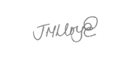
Mr A Brooks, Mrs A Handford, Mr S Walsh, Mrs K Barley,
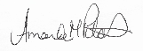
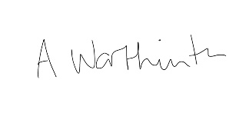
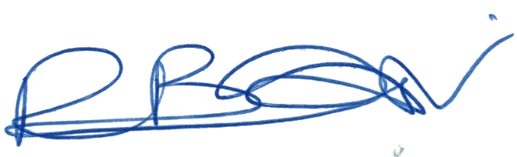
Mrs C Bellas, Mrs D Maxwell

