Richmond Hill Primary School – Geography 
Topic: My World and Me | Year: 2 | Strand:

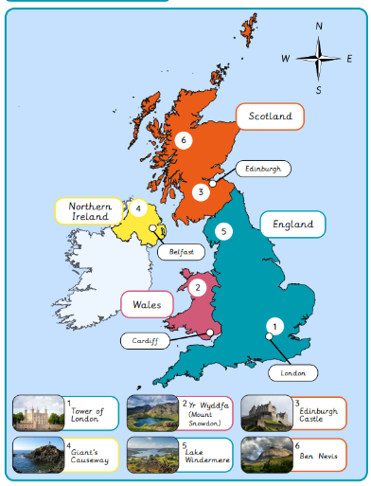
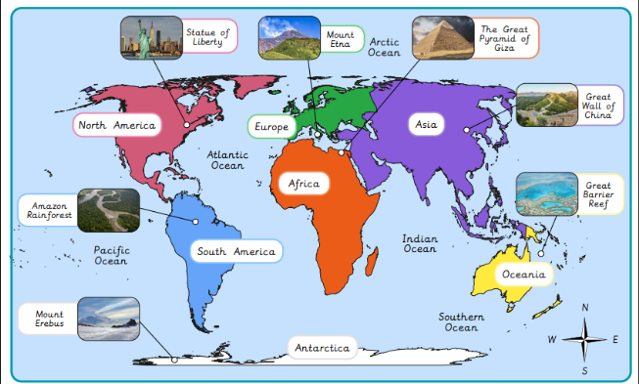
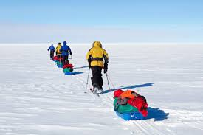
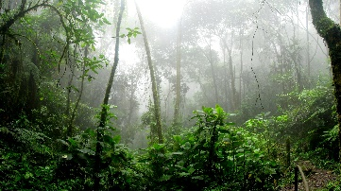
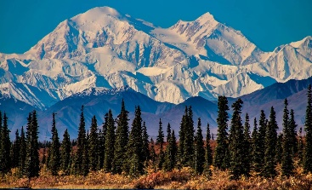
What will I know by the end of the unit?
Pupils who are secure will be able to:
- Identify and locate characteristics of the UK on a map.
- Identify human and physical features.
- Locate human and physical features on a world map.
- Explain the difference between oceans and seas.
- Name and locate the five oceans on a world map.
- Use an aerial photograph to draw a simple sketch map.
- Collect data by sketching findings on a map and completing a tally chart.
- Present their findings in a bar chart.

Vocabulary
Amazon | the largest tropical rainforest
capital city | London is the capital city of England and the UK
climate | the usual weather conditions
coastline | the land along a coast
continent | a large land mass split into countries
country | an area of land that is controlled by its own government
equator | an imaginary line around the middle of the Earth between the Tropics
features | everything you can see when you look across an area of land, including hills, rivers, buildings, trees, and plants
humid | a warm and damp, moist climate
London | the capital city of the UK
North Pole | the most northerly point of the earth
ocean | a huge body of salt water
season | there are four different seasons throughout the year
Sierra | a mountain range
South Pole | the most southerly point on the earth
tropical | in between the Tropics and very humid
United Kingdom | the country we live in
Venn diagram | a diagram to show links

What should I already know?
- There are seven continents around the world.
- There are five oceans around the world.
- Aspatria is in England, which is in the UK. The UK is within the continent of Europe.
- The capital city of the UK is London

Geographical Skills and Fieldwork
- Use an atlas to find the UK. Can you identify where you would find hot countries and cold countries?
- Can you name the five oceans and the seven continents?
- Can you identify which animals you would find in a hot climate and which animals you would find in a cold climate?

