Richmond Hill Primary School - Science
Topic: Properties and changes of materials | Year: 5 | Strand: Chemistry
- A variety of everyday materials including wood, plastic, glass, metal, water and rock.
- The physical properties of a variety of everyday materials (including those that are
transparent) and to compare and group materials on the basis of these properties
- How materials are suitably used based on their properties.
- How magnets and electrical circuits work.
- Some materials which are magnetic.
- How shapes of solid objects can be changed by squashing, bending, twisting and stretching.
- Materials that are solids, liquids and gases and their particle structure.
- Some materials change state when they are heated or cooled and the temperature at which this happens.
- Some rocks are permeable.
What should I already know?
What will I know by the end of the unit?
How to group materials based on their  properties using more complex  vocabulary. | 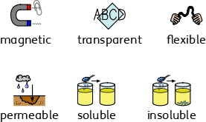
What are thermal insulators and  conductors? | - Materials which are good thermal conductors  allow heat to move through them easily.  - Thermal conductors are used to make items that require heat to travel through them easi- ly, such as a saucepan which requires heat to travel through to cook food.  - Thermal insulators do not let heat travel through them easily.  - Examples of thermal insulators include woollen clothes and flasks for hot drinks.  
What is  dissolving? | - When the particles of a solid mix with the  particles of a liquid, this is called dissolving.  - The result is a solution.  - Materials that dissolve are soluble.  - Materials that do not dissolve are insoluble.  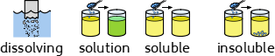
Can  materials be  separated after they have been mixed? | - Some materials can be separated after they have been mixed based on their properties - this is called a reversible change.  - Some methods of separation include the use of a magnet, a filter (for insoluble materials), a sieve (based on the size of the solids) and evaporation.  - When a mixture cannot be separated back into the original components, this is called an irreversible change. Examples of this include when materials burn or mixing bicarbonate of soda with vinegar.

Vocabulary
circuit | a complete route which an electric current can flow around
condensation | small drops of water which form when water vapour or steam touches  a cold surface, such as a window
conductor | a substance that heat or electricity can pass through or along
dissolves | when a substance is mixed with a liquid and the substance disappears
electricity | a form of energy that can be carried by wires and in used for heating  and lighting, and to provide power for devices
evaporation | to turn from liquid into gas; pass away in the form of vapour.
filtering | a device used to remove dirt or other solids from liquids or gases. A filter can be made of paper, charcoal, or other material with tiny holes  in it.
flexible | an object or material can be bent easily without breaking
gas | a form of matter that is neither liquid nor solid. A gas rapidly spreads out when it is warmed and contracts when it is cooled.
insoluble | impossible to dissolve, esp. in a given liquid.
insulator | a non-conductor of electricity or heat
irreversible | impossible to reverse, turn back, or change.
liquid | in a form that flows easily and is neither a solid nor a gas.
magnetic | having to do with magnets and the way they work
melting | to change from a solid to a liquid state through heat or pressure
particles | a tiny amount or small piece
permeable | of a substance, being such that gas or liquid can pass through it
process | a series of actions used to produce something or reach a goal.
properties | the ways in which an object behaves
rate | the speed with which something happens
resistance | the opposing power of one force against another.
reversible | able to turn or change back
solid | having a firm shape or form that can be measured in length, width, and height; not like a liquid or a gas
soluble | able to be dissolved.
solution | a mixture that contains two or more substances combined evenly
state | the structure or condition of something
temperature | a measure of how hot or cold something is
thermal | relating to or caused by heat or by changes in temperature
transparent | If an object is transparent, you can see through it
variable | something that can change or that has no fixed value

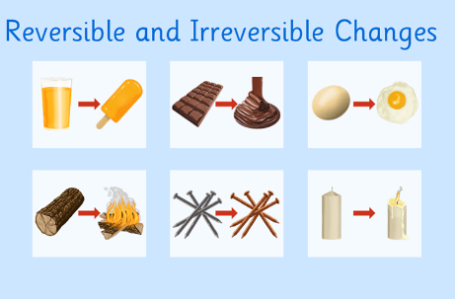
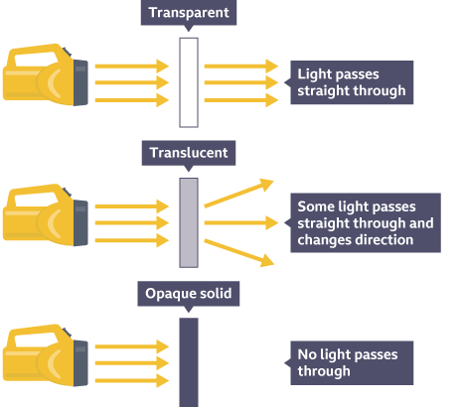
Diagrams
- Find the best material to stop an ice cube from melting. Remember to keep it a fair test by using the same number of ice cubes, or same size and thickness material.
- Place the same amount of a hot liquid in a thermal insulator and conductor. Measure the temperature over time and plot these on the same line graph. Use the line graph to ask and answer questions.
- Explain the difference between dissolving and melting.
- Investigate which materials are soluble and insoluble.
- Observe and compare the changes that take place when cakes are baked or bicarbonate of soda mixes with vinegar.
Investigate!

Richmond Hill Primary School - Science
Topic: Properties and changes of materials | Year: 5 | Strand: Chemistry
Question 7: Describe an efficient way of separating paper clips from rice and explain  why you chose this method. | Start of unit: | End of unit:

Question 1: Thermal insulators…(tick  two) | Start of  unit: | End of  unit:
do not allow heat to pass through
easily
allow heat to pass through easily
keep heat contained and keep things
warm
do not keep heat contained and
allow things to cool

Q2: Examples of good thermal  conductors are….(tick all that apply) | Start of unit: | End of unit:
a thermos flask
a sauce pan
woolen clothes
a radiator

Question 8: You conduct an experiment to investigate if some solids dissolve quicker than others. Name one thing you will do to  make the test fair. | Start of unit: | End of unit:

Question 3: Materials that dissolve  are: | Start of  unit: | End of  unit:
insoluble
soluble
a solution

Question 9: Match these mixtures to the most efficient methods of separation. | Start of  unit: | End of  unit:
salt and filtering
water

rice and sieving
water

sand and evaporating water

Question 4: When solid particles mix with the particles of a liquid, this is  called… | Start of unit: | End of unit:
evaporation
filtering
dissolving
sieving

Question 5: A synonym for the word  ‘permeable’ is... | Start of  unit: | End of  unit:
waterproof
absorbent
magnetic
transparent

Question 10: Write an ‘R’ or an ‘I’ to indicate if these are examples of  reversible or irreversible changes. | Start of unit: | End of unit:
frying an egg
mixing paper clips and sand
mixing sugar and water
baking a cake
mixing flour and water
mixing coins and flour
mixing bicarbonate of soda and vinegar
mixing oil and water

Question 6: Match these changes to  the scientific name for the process. | Start of  unit: | End of  unit:
ice turns to condensation water

water turns to
water vapour evaporation

water vapour melting turns to water

