
Knowledge Organiser: YEAR 5 Developing a Recipe
TOPIC | KEY SKILLS | KEY VOCABULARY
Topic: Cooking and Nutrition  Key focus: Developing a recipe | 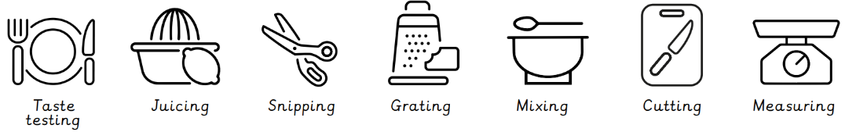  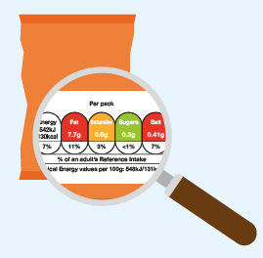  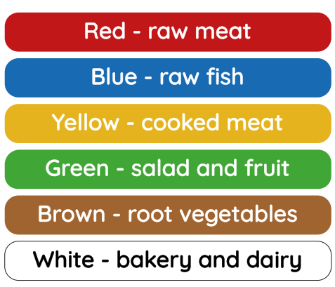  Nutritional information can help people make healthier choices.  Coloured chopping boards to prevent cross-contamination | adaptation  cook  cross-contamination  farm  hygiene  ingredients  label  nutrient  nutritional value  process
OBJECTIVES
- Know that beef comes from cows that are reared on farms.
- Understand that recipes can be adapted to suit nutritional and dietary needs.
- Know where to find nutritional information on food packaging.
- Understand that coloured chopping boards can prevent cross-contamination.

 | Design Examples
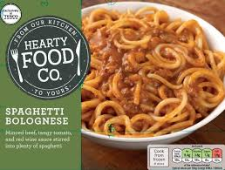
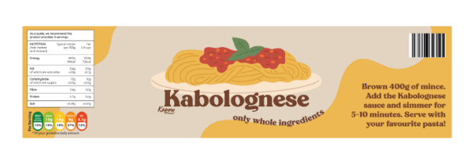
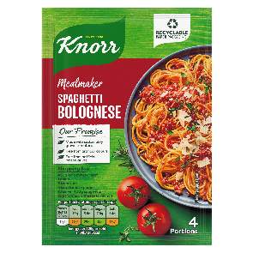
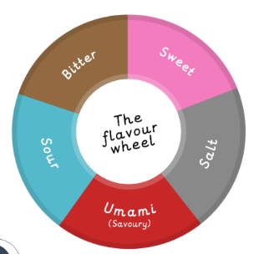
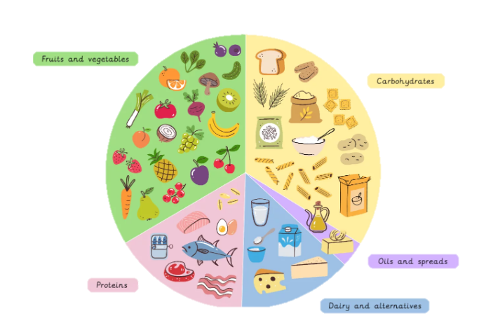
Product Labels
What flavour will your recipe be?
How will you adapt the recipe?

