Richmond Hill Primary School – Geography 
Topic: Would you like to live in the desert? | Year: 5 | Strand: Human and Physical Geography
Vocabulary
arid | too little rain to support lots of vegetation
barren | land that cannot grow vegetation
biome | an area of the world with similar climate and landscape, where similar plants and animals live
climate | long-term weather conditions in a specific region.
desert | any stretch of land with little to no rainfall, extremely sparse vegetation and wildlife
mining | the process of digging up valuable minerals from the Earth’s crust
rainfall | the amount of rain falling in a place over a particular time
equator | keeping animals on a large farm, particularly in the Americas
extinct volcano | energy generated from a continuous source, such as wind or water
volcano | a very deep hole in the Earth’s top layer  that can let out hot gasses, ash and lava

What should I already know?
- The Earth has different time zones.
- The earth is made up of six biomes; savannah, desert, temperate deciduous forest, tropical rainforest, boreal and tundra.
- Humans can contribute to physical features.
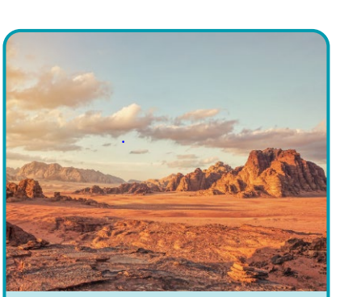
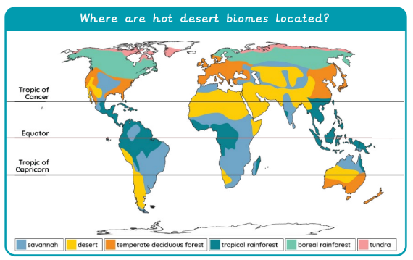
Diagrams

What will I know by the end of the unit?
How do humans use the desert? | - protected nature reserves  - for recreational purposes  - farming or ranching  - military purposes  - mining  - renewable energy  - tourism and settlement.
Does human activity contribute to the changing climate and landscape of a desert? | - Overgrazing, overcultivation, deforestation, and inappropriate irrigation can lead to desertification.
What are the threats to deserts? | - Droughts are a threat to a desert due to little rainfall and desert climate.  - Desertification can occur when fertile land becomes desert, leading to loss of vegetation and decreased biodiversity.  - Flash floods can move the sand and lead to soil erosion.
Why does the Mojave desert have a different time zone to the UK? | - The Mojave desert is located in a hot desert biome whereas the UK’s main biome is a temperate deciduous forest.
Geographical skills and fieldwork
- Can you identify the lines of latitude where hot desert biomes are located.
- Do you know the characteristics of a hot desert biome and can you describe them?
- Can you locate the largest deserts in each continent?
- Can you describe ways the Mojave Desert is used?
- Name and describe the physical features found in a desert.

