
Knowledge Organiser: YEAR 5 Installation Art
TOPIC | KEY SKILLS | KEY VOCABULARY
Topic: Installation Art  Media: sculpture, painting, textiles  Key artists: Charlie Whinney  Key focus: Creating a piece of Installation Art to affect the viewer | 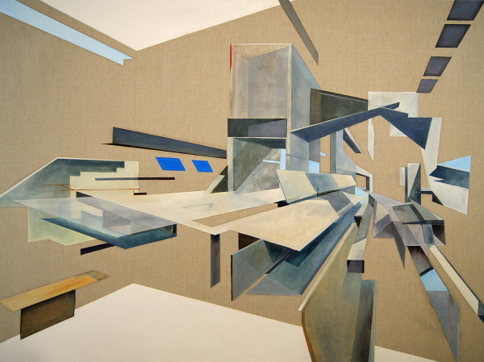  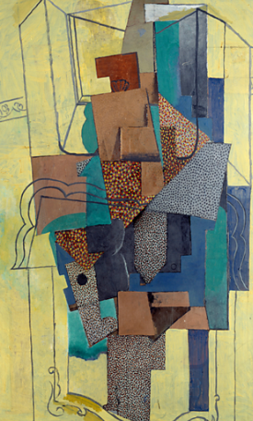  Using mixed media to create an affect  Using spatial awareness to create depth and drama to the piece. Thinking about the viewers perspective. | analyse  art medium  atmosphere  concept  elements  evaluate  features  influence  installation art  interactive  mixed media  performance art  scale
OBJECTIVES
• Develop ideas independently from their own research. Explore and record their plans, ideas and evaluations to develop their ideas towards an outcome.

• Work with a range of media with control in different ways to achieve different effects, including experimenting with the techniques used by other artists.

• Discuss how artists create work with the intent to create an impact on the viewer.

•Consider how effectively pieces of art express emotion and encourage the viewer to question their own ideas.

 | FOCUS ARTIST INSPIRATION
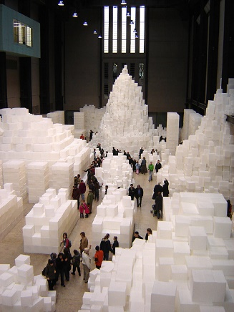
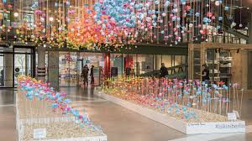
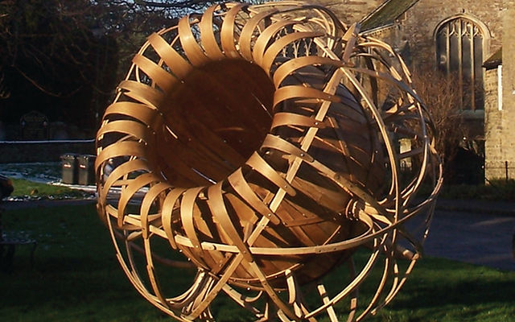
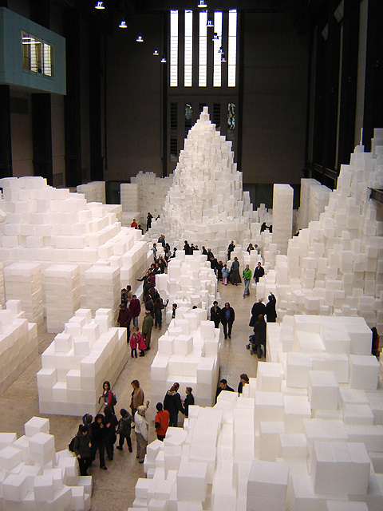
Charlie Whinney has made large projects in the UK, Asia, USA. He is the Laurent-Perrier Design Award winning product designer and has been commissioned to create a piece of Installation Art to fill the hole left when the sycamore tree was chopped down near Hadrian’s Wall.
Installation Art inspiration
A piece of Installation Art by Charlie Whinney

