
Knowledge Organiser: Pop Up Books
TOPIC | KEY SKILLS | KEY VOCABULARY
Topic: Mechanical Systems  Key focus: Pop Up Books | 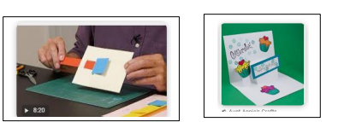  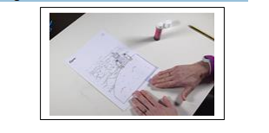  The surface decoration of products should include pictures and captions. When adding decoration, we need to consider the needs and preference of the user.  Spacers are used to create layers to hide mechanisms, making the look neater and more desirable. | aesthetic  design  design brief  design criteria  function  input  mechanism  motion  output  pivots  prototype  sliders  structure  template
OBJECTIVES
- Designing a pop-up book which uses a mixture of structures and mechanisms.
- Naming each mechanism, input and output accurately.
- Storyboarding ideas for a book.
- Following a design brief to make a pop up book, neatly and with focus on accuracy.
- Making mechanisms and/or structures using sliders, pivots and folds to produce movement.
- Using layers and spacers to hide the workings of mechanical parts for an aesthetically pleasing result.

 | Design Examples linkage
 | 

