
Knowledge Organiser: YEAR 5 Drawing – Depth, emotion and movement
TOPIC | KEY SKILLS | KEY VOCABULARY
Topic: Drawing – Depth, emotion and movement  Media: painting, drawing, printmaking  Key artist: Charlie Mackesy  Key focus: Using colour and line to portray movement and emotion in artwork. | 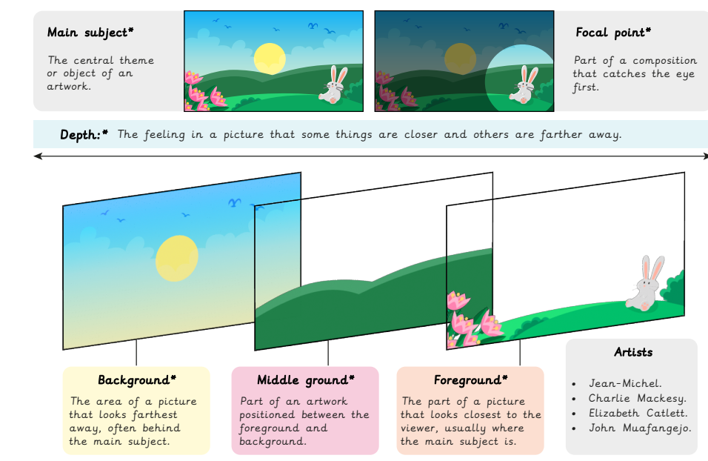 | background  composition  depth  focal point  foreground  main subject  middle ground  printing plate  printmaking  proportion
OBJECTIVES
- Develop ideas more independently from own research. Explore and record their plans, ideas and evaluations to develop their ideas towards an outcome.

- Work with a range of media with control in different ways to achieve different effects, including experimenting with the techniques used by other artists.

- Create in a more sustained way, revisiting artwork over time and applying their understanding of tone, texture, line, colour and form.

- Discuss how artists create work with the intent to create an impact on the viewer.

 | FOCUS ARTIST INSPIRATION
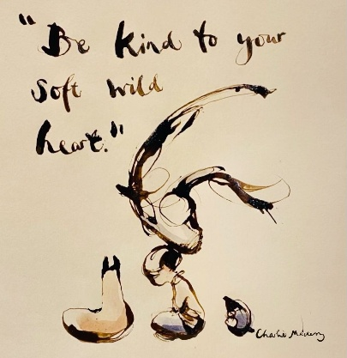
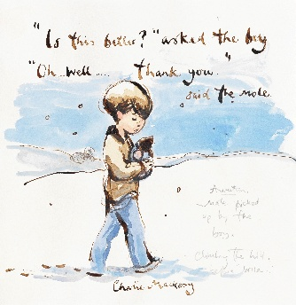
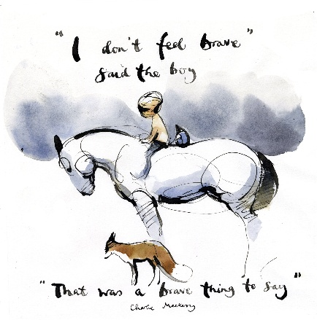
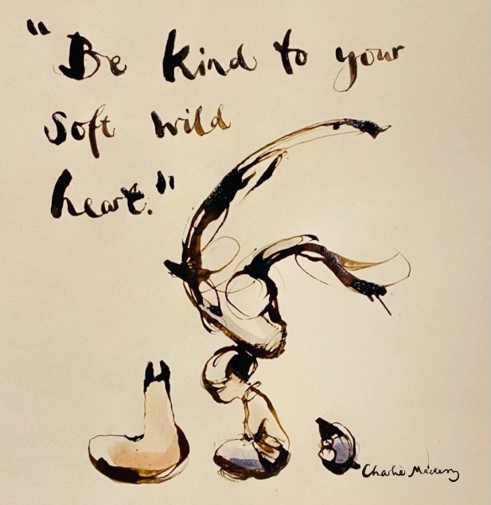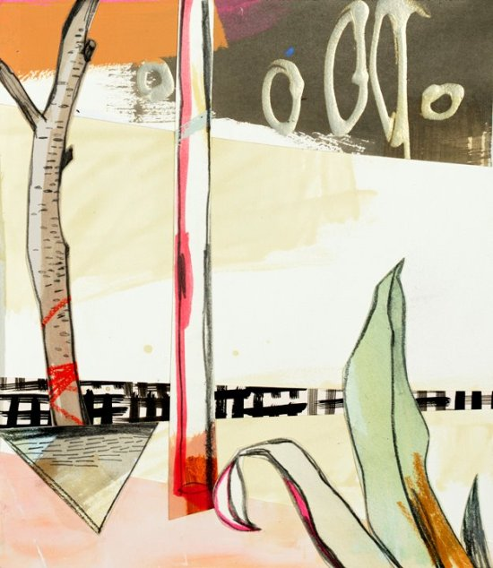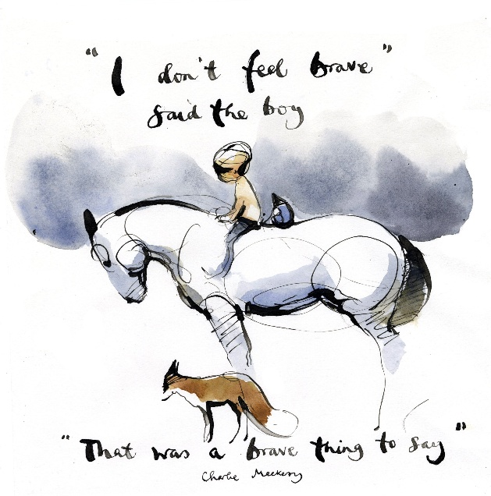
Charlie Mackesy is a British artist and illustrator who uses depth and emotion in his artwork to share messages of hope, encouraging people to share their feelings with others.

