Richmond Hill Primary School – Geography 
Topic: What is life like in the Alps? | Year: 5 | Strand: Human and Physical Geography
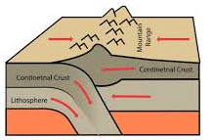
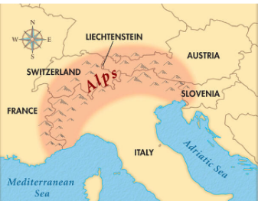
Diagrams

Vocabulary
atlas | A book of maps and charts
climate | Long-term weather patterns in a country or region
climate change | Long-term shifts in temperatures and weather patterns
enquiry | A question to be proved or disproved
fold mountain | A mountain created when two or more tectonic plates collide
glacier | A large, slow-moving mass of ice and sediment that forms on land.
hemisphere | Half of a sphere.
human feature | Things built by people; such as houses, roads and bridges.
land height | The vertical distance of a point on the Earth’s surface above sea level.
latitude | The measurement of how far north, or south of the equator a place is located.
leisure | A freely chosen activity or experience.
longitude | The measurement of how far east, or west of the prime meridian a place is located.
mountain climate | Climate found in the mountains; it gets colder at higher altitudes (higher up the mountain you go.
mountain range | A group of mountains, connected by high ground.
physical feature | A natural feature; such as a mountain, river or coastline.
population | The number of people living in a certain place.
temperate | A measure of how hot or cold something is.
tourism | When people travel from where they live for pleasure or relaxation.

What should I already know?
- The names and locations of the seven continents on Earth.
- Tectonic plates are underneath the surface the Earth.
- How to use an atlas to locate physical features of different countries.
- The earth is made up of six biomes; savannah, desert, temperate deciduous forest, tropical rainforest, boreal and tundra.
What will I know by the end of the unit?
How does  geographical  location influence  climate? | - Most of the Alps have a mountain climate. It is much colder than the surrounding climate due to the height of the mountains.  - Lower regions of the Alps have a temperate climate, due to the change in altitude.  - Altitude affects the climate.
What are the Alps? | - The Alps are in the Northern Hemisphere and are the highest mountain range located in Europe.  - The Alps stretch across eight countries: France, Monaco, Italy, Switzerland, Liechtenstein, Austria, Germany and Slovenia.  - The climate is generally temperate, with warm summers and cold winters.  - The Alps are fold mountains, the highest mountain in the alps is Mont Blanc  - The Alps are a popular tourist location, due to its physical features (Mont Blanc, Lake Worthersee, Pasterze) and its human features (Innsbruck cable car, Hohensalzburg Fortress and Ski Resorts)
What causes a mountain to form? | - Alpine mountains are fold mountains, they are formed when two, or more, tectonic collide and force the ground upwards.
Geographical skills and fieldwork
- Can you explain why mountain climates are different to the climate of places nearby?
- Can you describe how humans have an effect on an environment?
- Using a range of secondary sources research a mountain range holiday.
- Can you explain how climates have an impact on land uses, trade and settlements.

