
Knowledge Organiser: YEAR 5 Architecture
TOPIC | KEY SKILLS | KEY VOCABULARY
Topic: Architecture  Media: Sketching and Printmaking  Key artists: Zaha Hadid  Key focus: Designing a chalet for a Ski Resort in The Alps | 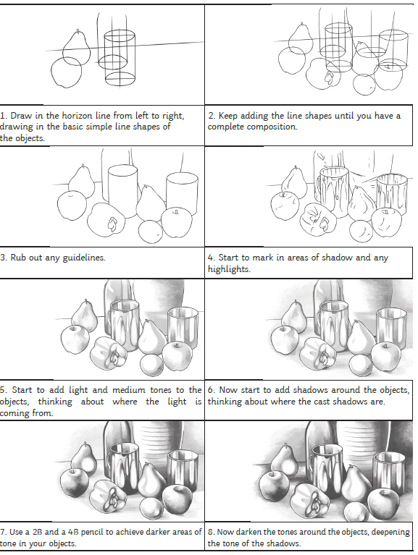  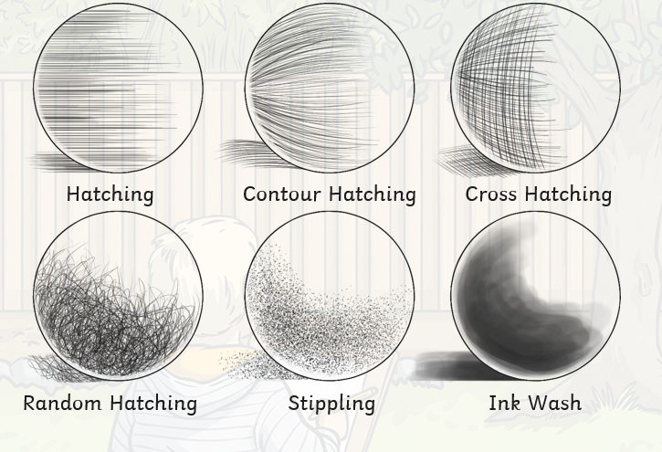 | abstract  architecture  built environment  composition  contemporary  design  elevation  form  monoprint  monument  observational drawing  perspective  proportion  tonal
OBJECTIVES
• Create sketch books to record their observations and use them to review and revisit ideas

• Improve their mastery of art and design techniques through using a combination of materials, construction methods and tools to design an architectural model, thinking about the environmental impact of the structure.

• Explore ideas relating to design; exploring thoughts about inspiration, materials, textures and colours.

• Explore and evaluate the intention of a design.

 | FOCUS ARTIST INSPIRATION
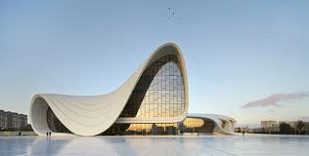
Dame Zaha Hadid was an Iraqi-born British architect, artist and designer. She is recognised as a key figure in the architecture of the late-20th and early-21st centuries. She was the first woman to receive the Pritzker Architecture Prize.
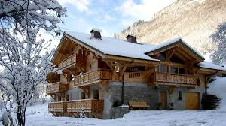
Chalet in The Alps
Zaha Hadid’s Design

