
Knowledge Organiser: YEAR 5 Drawing – I need space
TOPIC | KEY SKILLS | KEY VOCABULARY
Topic: Drawing – I need space  Media: painting, drawing, printmaking  Key artist: Larisa Murariu  Key focus: Impact of The Space Race on art and design. | 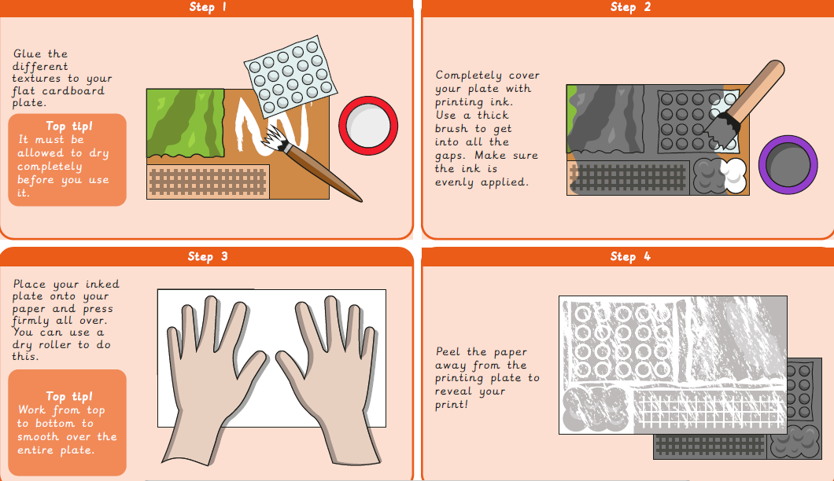 | collagraphy  composition  develop  evaluate  futuristic  imagery  printing plate  printmaking  purpose  Retrofuturism  stimulus  technique
OBJECTIVES
- Develop ideas more independently from own research. Explore and record their plans, ideas and evaluations to develop their ideas towards an outcome.

- Work with a range of media with control in different ways to achieve different effects, including experimenting with the techniques used by other artists.

- Create in a more sustained way, revisiting artwork over time and applying their understanding of tone, texture, line, colour and form.

- Discuss how artists create work with the intent to create an impact on the viewer.

 | FOCUS ARTIST INSPIRATION
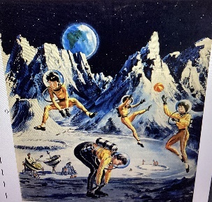
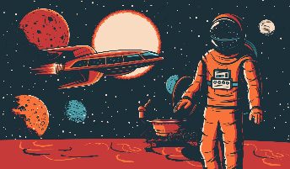
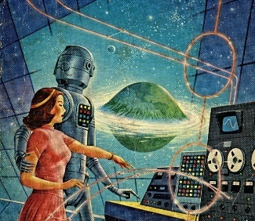
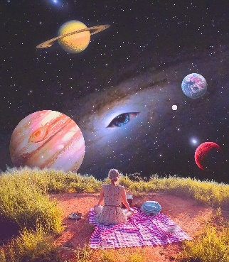
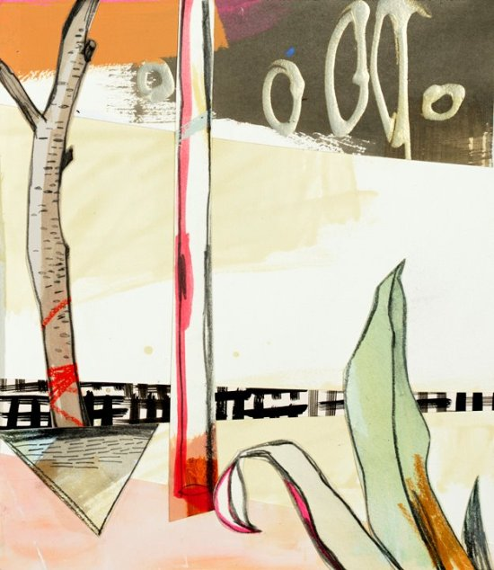
Retrofuturism
Morysetta
Larisa Murariu is a Romanian digital collage artist, Today, Larisa's own personal 'moon' goes by the name of Morysetta, an astronaut of the imagination. Her cosmic vision focuses on everyday objects and common emotions, transforming them into something special, just as magical as life itself

