
Knowledge Organiser: YEAR 5 Electrical Doodlers
TOPIC | KEY SKILLS | KEY VOCABULARY
Topic: Electrical Systems  Key focus: Doodlers | 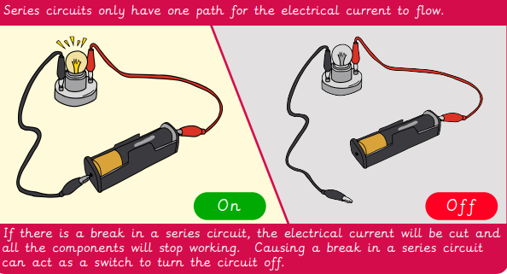 | circuit component  configuration  current  develop  DIY  investigate  motor  motorised  problem solve  product analysis  series circuit  stable  target user
OBJECTIVES
- Identifying factors that could be changed on existing products and explaining how these would alter the form and function of the product.
- Developing design criteria based on findings from investigating existing products.
- Altering a product’s form and function by tinkering with its configuration.
Making a functional series circuit, incorporating a motor.
- Constructing a product with consideration for the design criteria.
- Breaking down the construction process into steps so that others can make the product.
- Carry out a product analysis to look at the purpose of a product along with its strengths and weaknesses.

- Determining which parts of a product affect its function and which parts affect its form.

- Analysing whether changes in configuration positively or negatively affect an existing product.

- Peer evaluating a set of instructions to build a product.

 | Design Examples
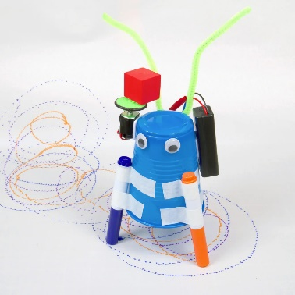
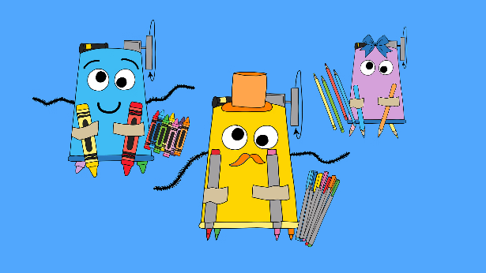
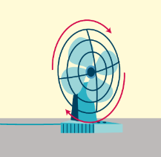
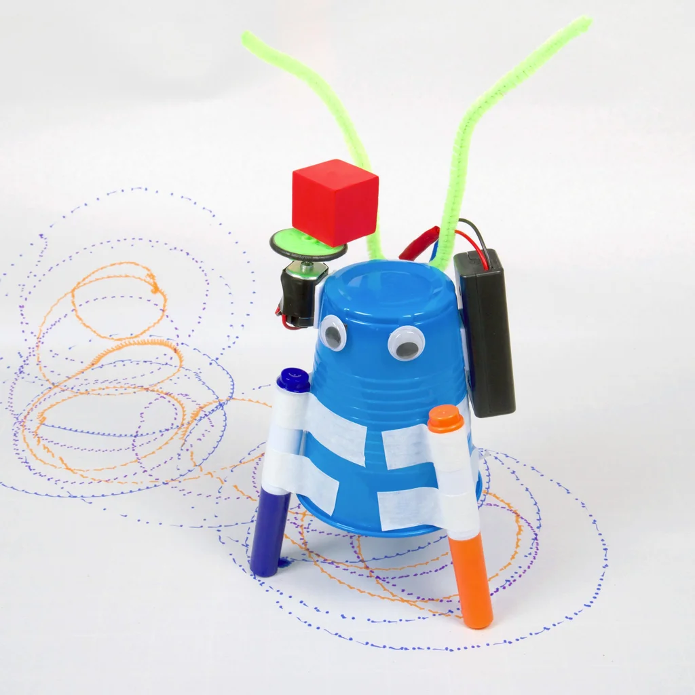
Electrical Scribblers
A fan uses a motor

Knowledge Organiser:
Topics | Key Skills | Key Vocabulary
Key Formulae/Rules
 | Things to Remember

Knowledge Organiser:
Model Answers

Knowledge Organiser:
Topics | Key Skills | Key Vocabulary
Key Formulae/Rules
 | Things to Remember

Knowledge Organiser:
Model Answers

Knowledge Organiser:
Topics | Key Skills | Key Vocabulary
Key Formulae/Rules
 | Things to Remember

Knowledge Organiser:
Model Answers

Knowledge Organiser:
Topics | Key Skills | Key Vocabulary
Key Formulae/Rules
 | Things to Remember

Knowledge Organiser:
Model Answers

