
Knowledge Organiser: YEAR 5 Monitoring Devices
TOPIC | KEY SKILLS | KEY VOCABULARY
Topic: Digital World  Key focus: Monitoring Devices | 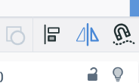  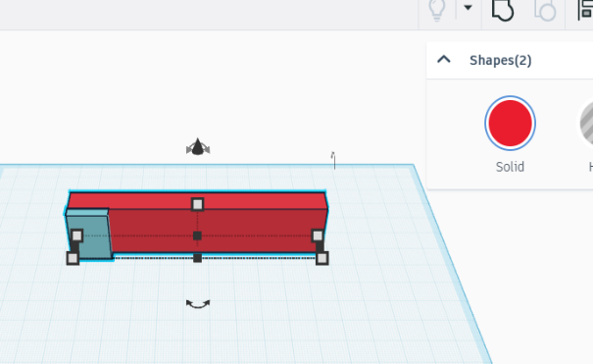  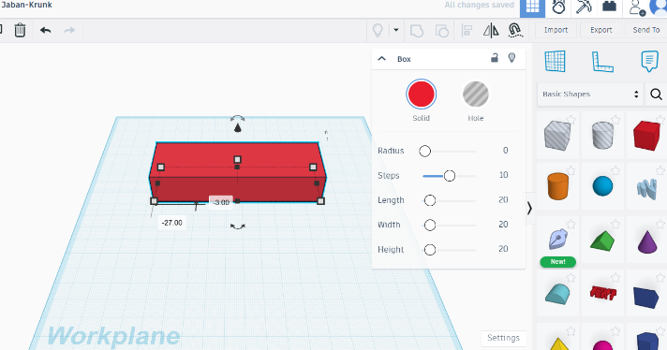  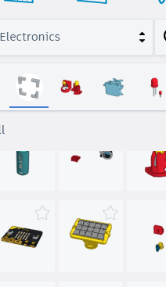  Align  Micro:bit  Group objects  Tinkercad adding shapes | alert  ambient  boolean  CAD  device  electronic  loop  model  monitoring device  plastic pollution  sensor  synthetic  thermometer  Tinkercad
OBJECTIVES
- Develop design criteria based on research.
- Generate multiple housing ideas using building bricks.
- Understand what a virtual model is and the pros and cons of traditional and CAD modelling.
- Place and manoeuvre 3D objects using CAD.
- Change the properties of or combine one or more 3D object using CAD.
- Programme to monitor the ambient temperature and coding an (audible or visual) alert when the temperature moves out of a specified range.

 | Design Examples

Security alarm systems use motion detectors to sense movement in an unwarranted place.


Fire alarms can detect smoke, and some can also detect abnormally high temperatures.

Today we have a range of safe non-toxic, smart and digital thermometers: 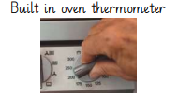 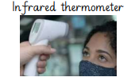

Knowledge Organiser:
Topics | Key Skills | Key Vocabulary
Key Formulae/Rules
 | Things to Remember

Knowledge Organiser:
Model Answers

Knowledge Organiser:
Topics | Key Skills | Key Vocabulary
Key Formulae/Rules
 | Things to Remember

Knowledge Organiser:
Model Answers

Knowledge Organiser:
Topics | Key Skills | Key Vocabulary
Key Formulae/Rules
 | Things to Remember

Knowledge Organiser:
Model Answers

Knowledge Organiser:
Topics | Key Skills | Key Vocabulary
Key Formulae/Rules
 | Things to Remember

Knowledge Organiser:
Model Answers

