
Knowledge Organiser: YEAR 5 Painting – Portraits
TOPIC | KEY SKILLS | KEY VOCABULARY
Topic: Painting– Portraits  Media: Collage, painting, mixed media  Key artist: Chila Kumari Singh Burman  Key focus: Mixed Media Self Portraits | 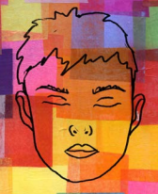 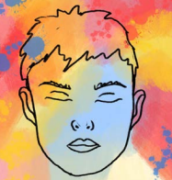 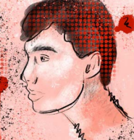  Collage Paint Wash Mixed Media | art medium  atmosphere  background  carbon  collage  composition  evaluate  mixed media  multimedia  printmaking  self-portrait  texture
OBJECTIVES
- Work with a range of media with control in different ways to achieve different effects, including experimenting with the techniques used by other artists.

- Combine a wider range of media, e.g. photography and digital art effects.

- Create in a more sustained way, revisiting artwork over time and applying their understanding of tone, texture, line, colour and form.

- Research and discuss the ideas and approaches of artists across a variety of disciplines, being able to describe how the cultural and historical context may have influenced their creative work.

- Discuss the processes used by themselves and by other artists, and describe the particular outcome achieved.

 | FOCUS ARTIST INSPIRATION
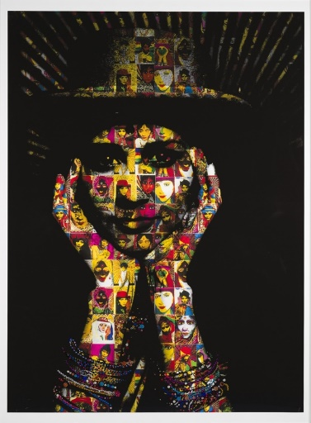
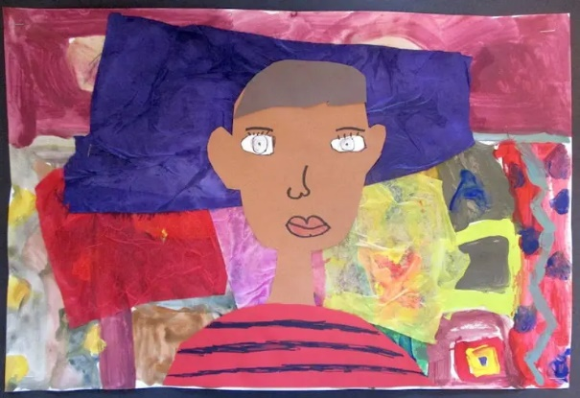
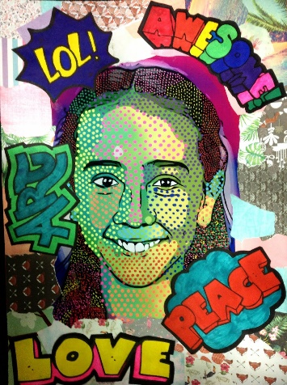
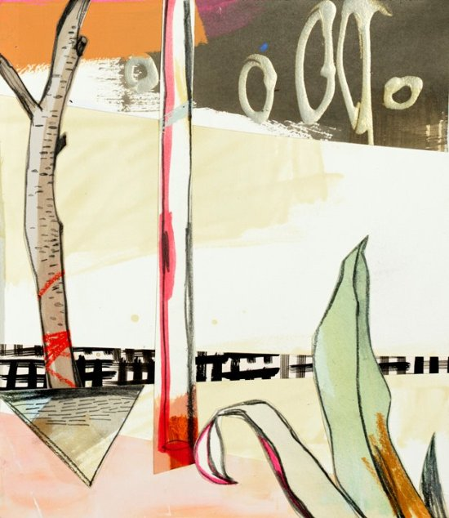
Chila Kumari Singh Burman is a British artist, she works across a wide range of mediums including printmaking, drawing, painting, installation and film.
Chila Kumari Singh Burman’s work
Mixed Media Self-Portraits

