
Knowledge Organiser: YEAR 5 Bridges
TOPIC | KEY SKILLS | KEY VOCABULARY
Topic: Structures  Key focus: Bridges | 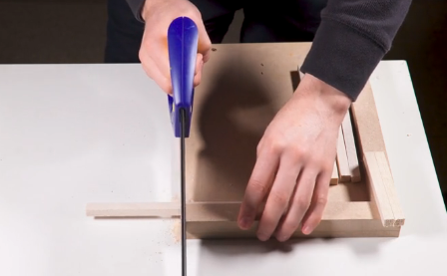  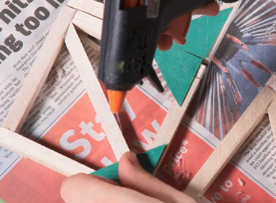  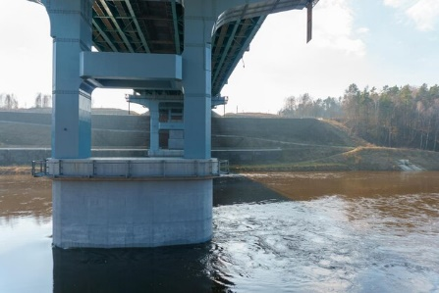  Safely cut the wood, keeping hands away from the blade.  Add strength in the corners to reinforce.  Wide bass supports a structure | accurate  arch bridge  beam bridge  compression  reinforce  set square  try square  shape  structure  suspension bridge  tension  truss Bridge
OBJECTIVES
- Understand some different ways to reinforce a structure.
- Understand how triangles can be used to reinforce a bridge.
- Know that properties are words that describe the form and function of materials.
- Understand why materials are selected based on their properties.
- Understand the material and properties of wood.
 | Design Examples
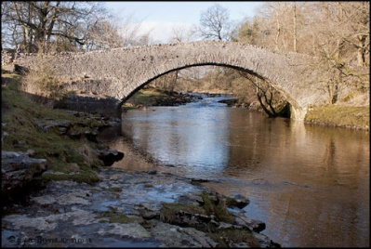
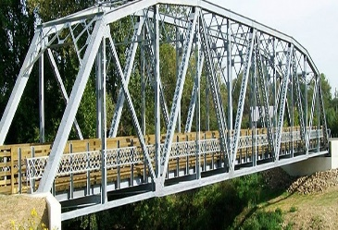



Truss Bridge
Suspension Bridge
Beam Bridge
Arch Bridge

