
Knowledge Organiser: YEAR 5 Textiles
TOPIC | KEY SKILLS | KEY VOCABULARY
Topic: Textiles  Key focus: Stuffed Toys | 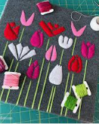  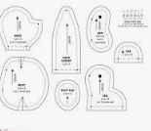  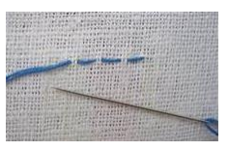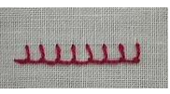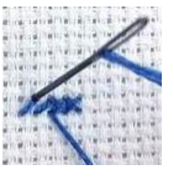  Cross Stitch  Applique  Template  Running Stitch  Blanket Stitch | Appendages  Blanket stitch  Running stitch  Cross stitch  Templates  Appliqué  Pattern  Template  Seam  Seam Allowance Aesthetic
OBJECTIVES
- Design a stuffed toy, considering the main component shapes required and create an appropriate template.
- Join two pieces of fabric using a blanket stitch.
- Use appliqué or decorative stitching to decorate the front of the stuffed toy.
- Use a blanket stitch to assemble the stuffed toy, repairing when needed.
- Develop stitching skills: cross stitch, running stitch, blanket stitch.
- Use evaluation skills to discuss what worked well and what could be improved.
 | Design Examples
 | 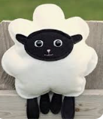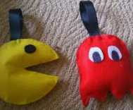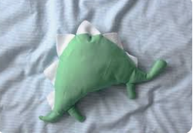

Knowledge Organiser:
Topics | Key Skills | Key Vocabulary
Key Formulae/Rules
 | Things to Remember

Knowledge Organiser:
Model Answers

Knowledge Organiser:
Topics | Key Skills | Key Vocabulary
Key Formulae/Rules
 | Things to Remember

Knowledge Organiser:
Model Answers

Knowledge Organiser:
Topics | Key Skills | Key Vocabulary
Key Formulae/Rules
 | Things to Remember

Knowledge Organiser:
Model Answers

Knowledge Organiser:
Topics | Key Skills | Key Vocabulary
Key Formulae/Rules
 | Things to Remember

Knowledge Organiser:
Model Answers

