Richmond Hill Primary School – Geography 
Topic: What is Greece Like? | Year: 5 | Strand: Place Knowledge/Human and Physical Geography
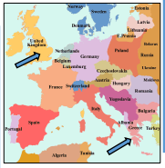
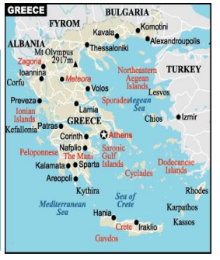
Diagrams

Vocabulary
atlas | A book of maps and charts
architecture | Planning, designing and constructing buildings.
climate | The weather conditions that are typical of a place.
coastal | An area of land close to the sea.
export | Goods that are sold to other countries.
human feature | Things built by people; such as houses, roads and bridges.
mountain range | A series of mountains connected in a line
peninsula | A piece of land almost surrounded by water
physical feature | A natural feature; such as a mountain, river or coastline.
population | The number of people living in a certain place.
temperate | A measure of how hot or cold something is.
tourism | When people travel from where they live for pleasure or relaxation.
vegetation | Plants, trees or flowers.

What should I already know?
- The geographical similarities and differences through the study of human and physical geography within their last unit of work.
- Know types of settlement and land use, economic activity including trade links, and distribution of natural resources including energy, food, minerals and water.
- Know the names of the continents and 5 oceans of the world.
- That England is in Europe, as well as the names of some other European countries.
What will I know by the end of the unit?
Where is Greece? | - Greece is in Southern Euroupe.  - The capital of Greece is Athens.  - Greece has thousands of islands.
What is Greece like compared to the UK? | - Both countries are in Europe: the UK is in northern Europe & Greece in southern Europe.  - Due to its more southerly position (closer to the Equator) Greece is warmer than the UK. On average, Athens is 9°C hotter than London.  - Greece is smaller than the UK – 131,957 sq. km compared to 243,610sq km.  - Significantly more people live in the UK – 66 million compared to 10.8 million. -London has a much larger population than Athens: 8.4 million compared to 3.1 million.  - Greece has higher mountains than the UK. Mt. Olympus is 2.917m high. The highest in the UK is Ben Nevis, at 1,345m.
How does tourism affect Greece? | - Greece has a long and rich history, and a culture which has developed over thousands of years from the time of the Ancient Greeks. Its warm climate also makes it a popular holiday destination for people from across the world.  - Greece is a part of the European Union and its currency is the Euro. Greece has suffered many financial problems in recent years, and have had to be helped by other countries. Tourism is a large source of income for Greece.
Geographical skills and fieldwork
- Can you explain where Greece is located?
- Can you describe how tourism affects Greece?
- Can you explain how climates have an impact on land uses, trade and settlements.
- Locate Greece and its coastline on a map.
- Using a range of sources, can you compare the human and physical features of the UK and Greece?

