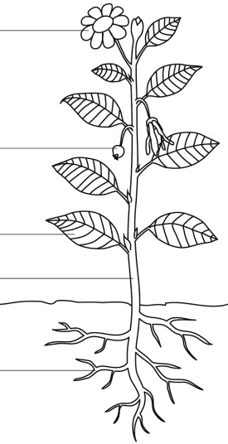
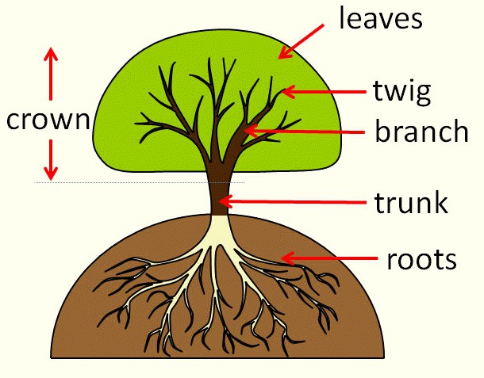
- Sort through pictures to show which things are living, which are dead and things which have never been alive.
- Go on a plant/tree hunt. What do you notice about what they look like? What are their features?
- Plant a bulb or a seed and watch it grow. Record your
observations in a diary. Compare the growth of that plant with a plant (using the same bulb or seed) where one of the conditions is different (no water, no light, a smaller container).
- Plant a seed on a wet cotton bud. Does it grow? Why might it grow for a little while and then stop?
- Dissect a variety of fruits and locate where their seeds are.
- Eat a variety of vegetables and identify which part of the plant they come from (note: do not taste nuts in school as they are allergens).
- Create a bar chart to show how tall your plants are to the nearest cm.

Investigate!
What will I know by the end of the unit?
Plants are living things and require things to grow. | - Plants require things such as water, warmth,  nutrients from soil and light to grow.  - If they do not have one or more of these things, they may stop growing.  - Plants can:  - move  - grow  - react to their surroundings (sense)  - absorb nutrients  - reproduce
Which plants do we eat? | - Many plants provide us with food by bearing  fruits which carry their seeds.  - When farmers grow plants to provide us with food, these are called crops.  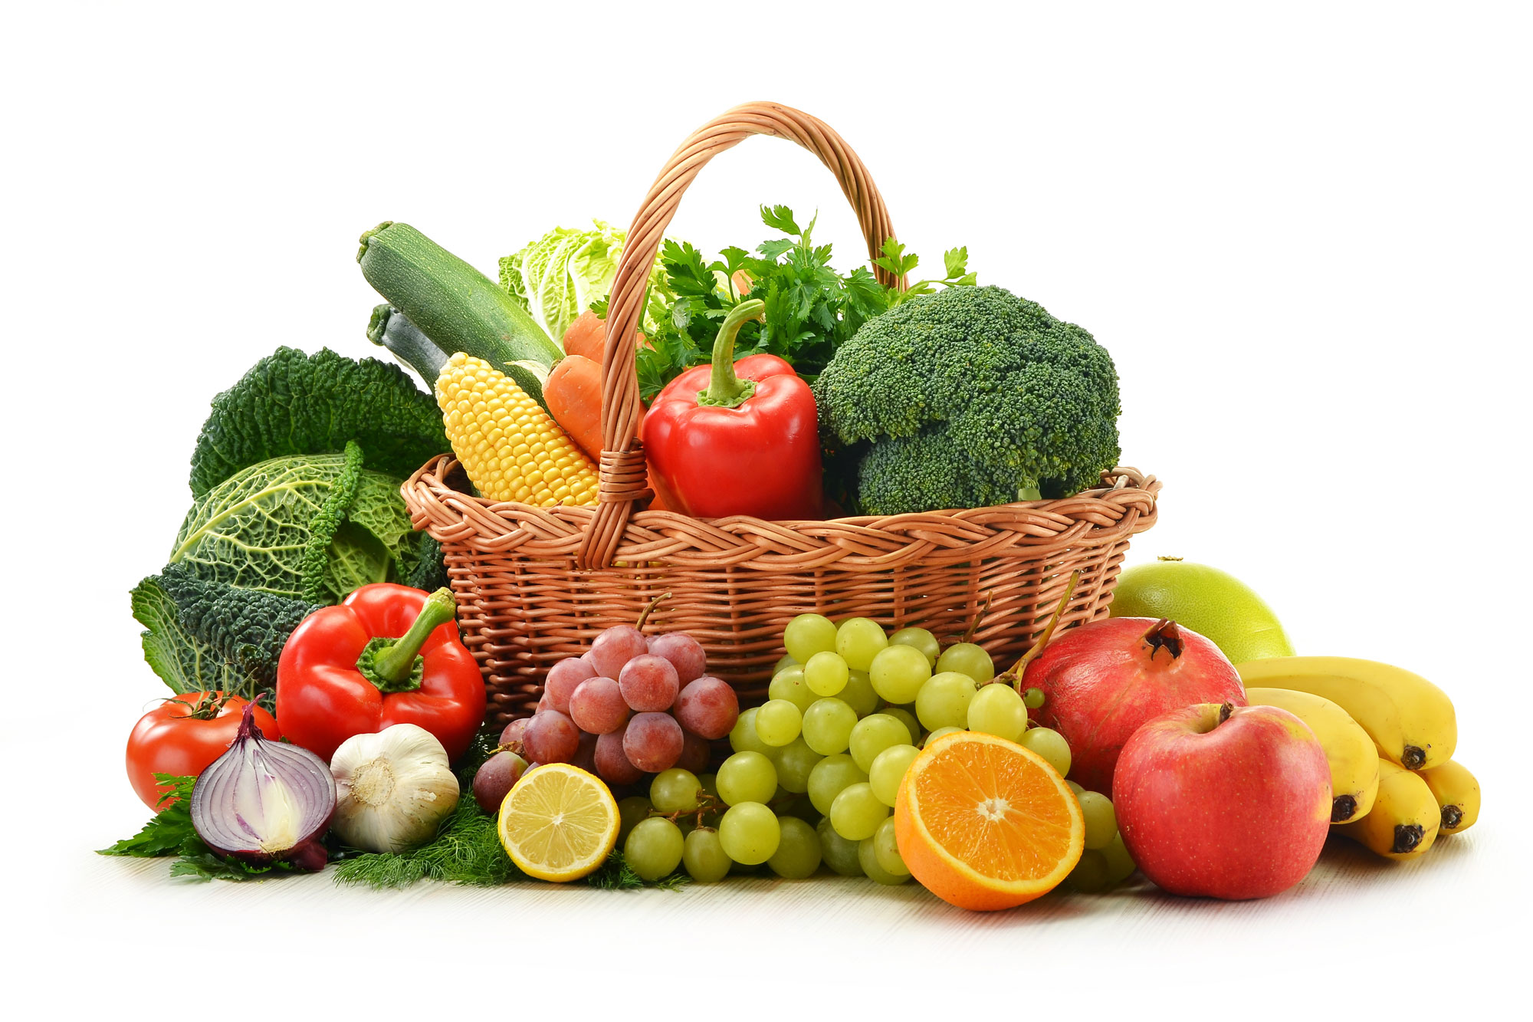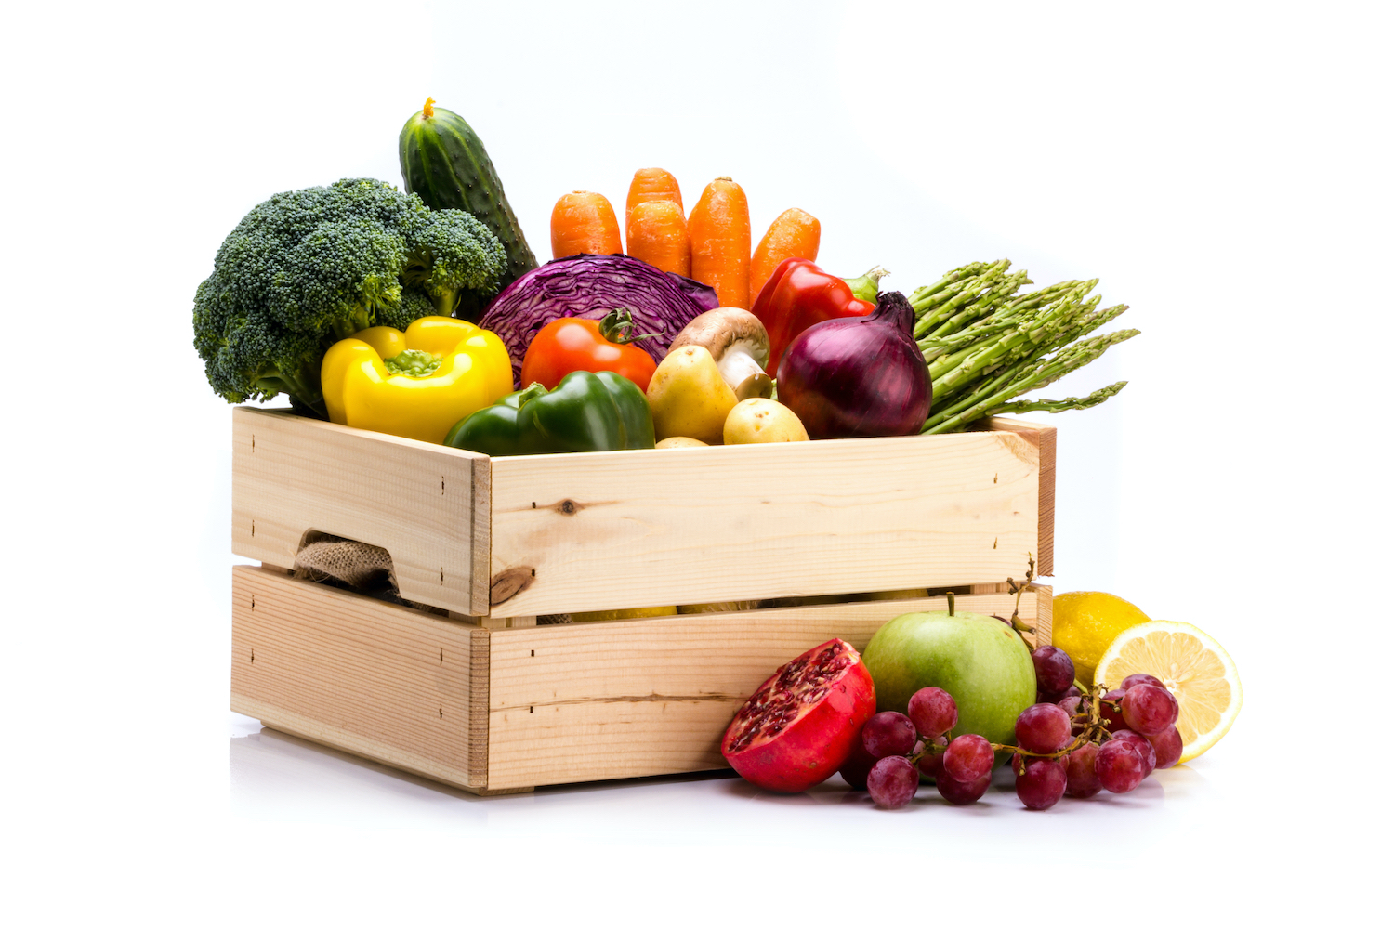  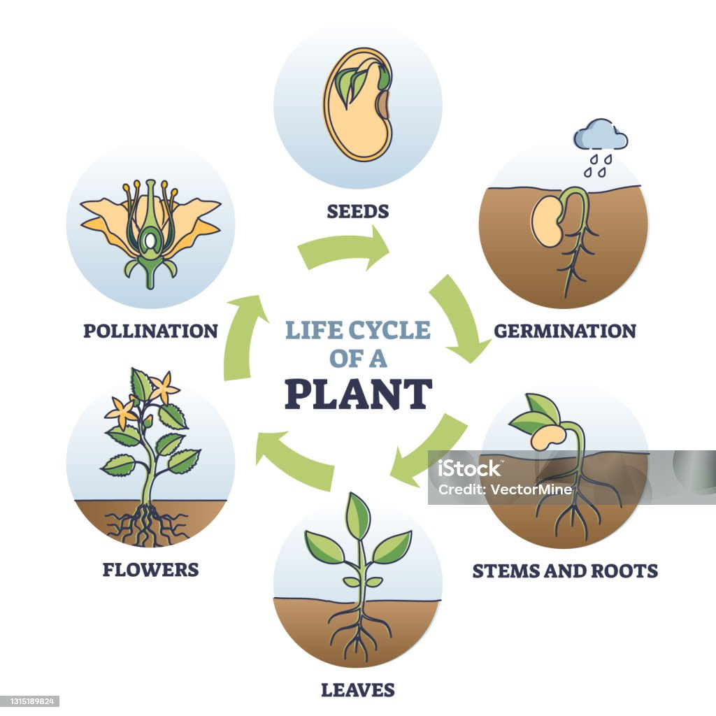
What are the parts of common trees and plants? | flower  seed  leaf  stem roots

- Plants can grow.
- The names of some common garden plants (e.g. poppy, rose) and the names of some common wild plants (e.g. daisy, dandelion, nettle).
- Deciduous trees lose their leaves in the autumn every year.
- Evergreen trees have green leaves all year round.
- The parts of a plant including petals, fruits, roots, bulbs, seeds, stem, trunks and branches.
What should I already know?
Vocabulary
bulb | a root shaped like an onion that grows into a  flower or plant
crop | plants such as wheat and potatoes that are grown  in large quantities for food
deciduous | a tree that loses its leaves in the autumn every  year
evergreen | a tree or bush which has green leaves all the year  round
flower | the part of a plant which is often brightly  coloured and grows at the end of a stem
flowering | trees or plants which produce flowers
fruit | something which grows on a tree or bush and which contains seeds or a stone covered by a sub-  stance that you can eat
leaf /  leaves | the parts of a tree or plant that are flat, thin, and  usually green
nutrients | substances that help plants and animals to grow
petal | thin coloured or white parts which form part of the  flower
plant | a living thing that grows in the earth and has a  stem, leaves, and roots
reproduce | when an animal or plant produces one or more  individuals similar to itself
roots | the parts of a plant that grow under the ground
seed | the small, hard part from which a new plant grows
stem | the thin, upright part of a plant on which the  flowers and leaves grow
tree | a tall plant that has a hard trunk, branches, and  leaves
vegetable | plants such as cabbages, potatoes, and  onions which you can cook and eat
vegetation | plants, trees and flowers
weed | a wild plant that grows in garden and prevents the  plants that you want from growing properly

Question 1: Which three living processes do plants do? | Start of unit: | End of unit:
move
grow
walk
reproduce

Question 2: Which three things does a plant need to grow well? | Start of unit: | End of unit:
water, exercise, wind
soil, water, wind
soil, sunlight, water
water, darkness, soil

Question 3: What is happening in this picture?  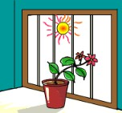 | Start of unit: | End of unit:
the plant has fallen over
the plant is growing towards the light
the roots are not strong enough to keep the plant straight
the flower is trying to look out of the window

Question 4: Four identical seeds have been planted at the same time.  Which of them will produce the tallest and healthiest seedling? | Start of unit: | End of unit:
The seed that has been watered and kept in the cupboard.
The seed that has been watered and kept in a fridge.
The seed that has been placed on a wet cotton ball.
The seed that has been watered and placed on a windowsill.

Question 5: Match these vegetables to the part of the plant they come  from: | Start of unit: | End of unit:
root cauliflower

stem carrot

leaf cabbage

flower celery

