Richmond Hill Primary School - Science 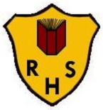
Topic: Animals including humans | Year: 2 |  | Strand: Biology
What should I already know?
- There are five types of vertebrates (mammals, fish, reptiles, amphibians, birds)
- Vertebrates are animals that have a backbone.
- Some animals are suitable to be kept as pets but others are not.
- Some animals give birth to live young but others lay eggs.
- Doctors and nurses give us medicine when we are poorly.
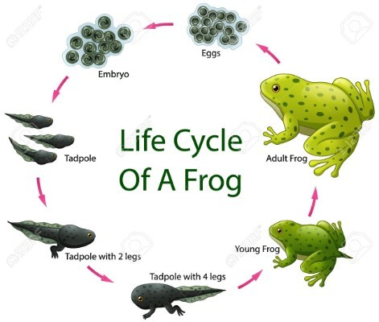
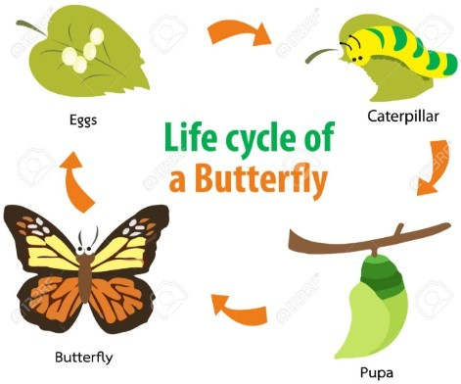
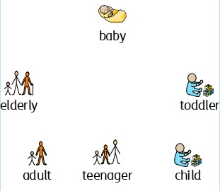
What will I know by the end of the unit?
What is a life cycle? | - A life cycle is the series of changes that an animal or plant passes through from the beginning of its life until its death.  - Animals, including humans, have offspring which grow into adults.
What do all animals need  to survive? | All animals need water, air and food to survive.
What do humans need to be healthy? | To keep healthy, humans need:  - to eat a balanced diet and healthy food  - some exercise to keep their muscles and bones healthy  - to take medicines that are given by doctors and nurses when feeling poorly  - to keep good hygiene by washing regularly, having clean clothes, brushing teeth and hair.

Vocabulary
backbone | the column of small linked bones down the  middle of your back
balanced diet | a variety of food that you regularly eat
bar chart | a chart which uses bars to represent the value of something and comparing it to a different group  
disease | an illness which affects people, animals, or plants
exercise | When you exercise, you move your body energetically in order to get fit and to  remain healthy
healthy | well and not suffering from any illness
hygiene | keeping yourself and your surroundings clean, especially in order to prevent illness or  the spread of diseases
life cycle | the series of changes that an animal or plant passes through from the beginning of its life  until its death
offspring | a person's children or an animal's young
pictogram | a simple drawing that represents something  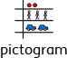
skeleton | the framework of bones in your body
survive | continue to exist
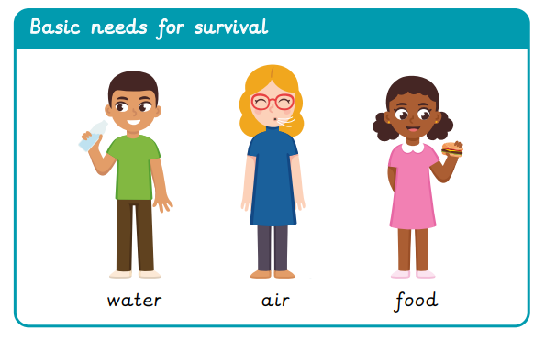
- Match animals to their offspring
- Compare and contrast offspring to their parents.
- Compare the heights/hand spans of people at different stages of their lives.
- Order the stages in human life.
- Write an instruction text about how to look after pets.
- Investigate how animals are cared for in zoos and farms.
- Record a food diary and evaluate your diet.
- Collect information about favourite foods and present it in a
pictogram or bar chart.
- Participate in a series of exercises and investigate how each
exercise:
  - makes your body feel
  - affects your breathing
  - uses each of your muscles
Investigate!

Richmond Hill Primary School - Science
Topic: Animals including humans | Year: 2 | Strand: Biology

Question 1: Tick all the things that all animals need to survive: | Start of unit: | End of unit:
water
exercise
air
food

Question 2: How can humans keep healthy? | Start of unit: | End of unit:
exercise
balanced diet
medicine when given by a doctor or nurse
look after animals

Question 3: The word offspring means….: | Start of unit: | End of unit:
a form of gymnastics
to go on and then off
a season of the year
a person’s children or an animal’s young

Question 4: Place these in order of how they happen in the  life cycle of a human: | Start of unit: | End of unit:
toddler
elderly
adult
baby

Question 5: How can you maintain good personal hygiene? | Start of unit: | End of unit:
brush teeth
wash regularly
brush hair
wear clean clothes
all of the above

