
Knowledge Organiser: YEAR 2
TOPIC | KEY SKILLS | KEY VOCABULARY
Topic: Cooking and Nutrition  Media: A balanced diet | Skills  - Chopping foods safely to make a wrap.  - Grating foods to make a wrap.  - Snipping smaller foods instead of cutting.  - Spreading soft foods to make a wrap.  - Identifying the five food groups.  - Learning about a balanced diet.  - Tasting and evaluating different food combinations.  - Describing appearance, smell and taste.  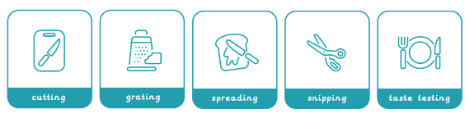  - Designing three wrap ideas. | 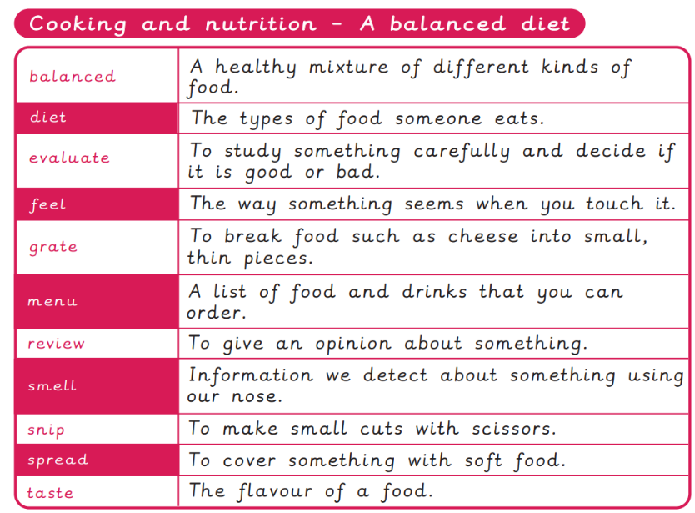
OBJECTIVES
Pupils who are secure will be able to:
- Name the main food groups and identify foods that belong to each group.
- Describe the taste, feel and smell of a given food.
- Think of three different wrap ideas, considering flavour combinations.
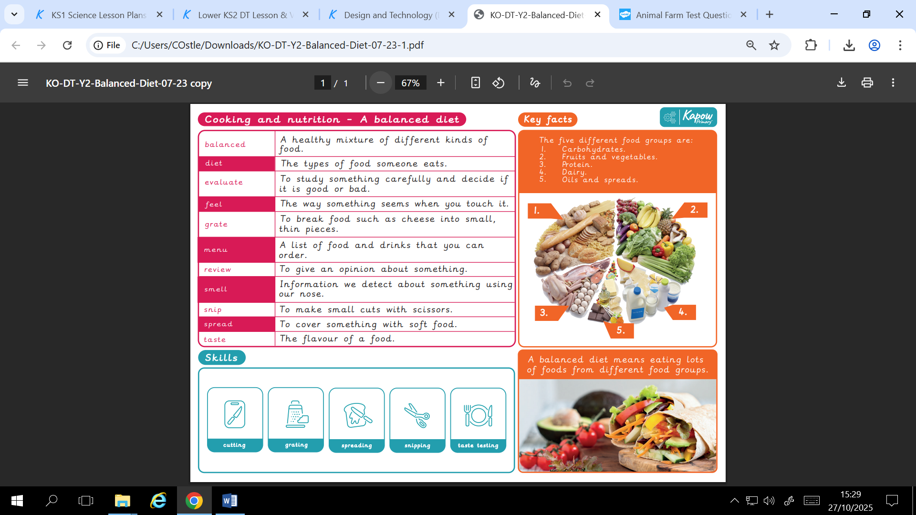
- Construct a wrap that meets the design brief and their plan.

 | FOCUS ARTIST INSPIRATION


