
Knowledge Organiser: YEAR 2
TOPIC | KEY SKILLS | KEY VOCABULARY
Topic: Structure and 3D  Media: Clay houses | Skills  Generating ideas:  Begin to generate ideas from a wider range of stimuli, exploring different media and techniques.  Using sketchbooks:  Experiment in sketchbooks, using drawing to record ideas.  Use sketchbooks to help make decisions about what to try out next.  Making skills:  Further demonstrate increased control with a greater range of media.  Use hands and tools with confidence when cutting, shaping and joining paper, card and malleable materials.  Evaluating and analysing:  Explain their ideas and opinions about their own and others’ artwork, beginning to recognise the stories and messages within in and showing an understanding of why they may have made it.  Begin to talk about how they could improve their own work. | - casting  - ceramic  - cut  - detail  - flatten  - glaze  - impressing  - in relief  - join  - negative space  - pinch pot  - plaster
OBJECTIVES
Pupils who are secure will be able to:
- Flatten and smooth their clay, rolling shapes successfully and making a range of marks in their clay.
- Make a basic pinch pot and join at least one clay shape onto the side using the scoring and slipping technique.
- Roll a smooth tile surface.
- Join clay shapes and make marks in the tile surface to create a pattern.
- Draw a house design and plan how to create the key features in clay.
- Create a clay house tile that has recognisable features made by both impressing objects into the surface and by joining simple shapes.
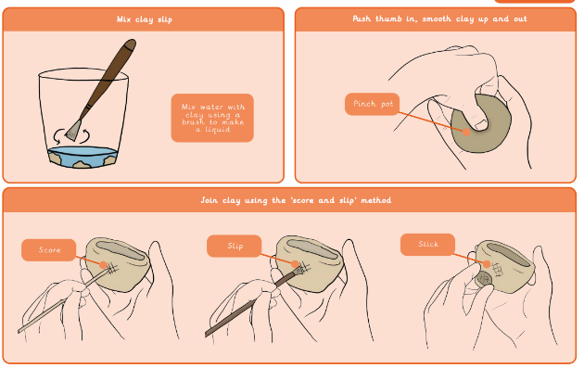
 | FOCUS ARTIST INSPIRATION
Knowledge of artists:
Talk about art they have seen using some appropriate subject vocabulary.
Create and critique both figurative and abstract art, recognising some of the techniques used.
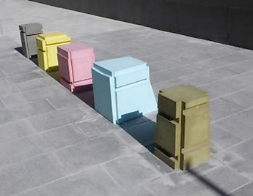
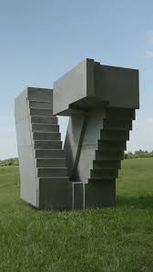
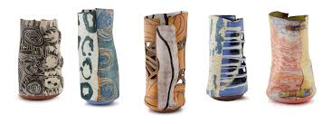
Ranti bam Racheal Whiteread

