
Knowledge Organiser: YEAR 2
TOPIC | KEY SKILLS | KEY VOCABULARY
Topic: Drawing:  Media: Understanding tone and texture | Skills  Generating ideas  Beginning to generate ideas from a wider range of stimuli, exploring different media and techniques.  Using sketchbooks  Experimenting in sketchbooks, using drawing to record ideas.  Using sketchbooks to help make decisions about what to try out next.  Making skills  Demonstrating increased control with a greater range of media.  Making choices about which materials and techniques to use to create an effect.  Developing observational skills to look closely and aim to reflect some of the formal elements of art (colour, pattern, texture, line, shape, form and space) in their work.  Evaluating and analysing  Explaining their ideas and opinions about their own and others’ artwork, beginning to recognise the stories and messages within in and showing an understanding of why they may have made it.  Beginning to talk about how they could improve their own work. | 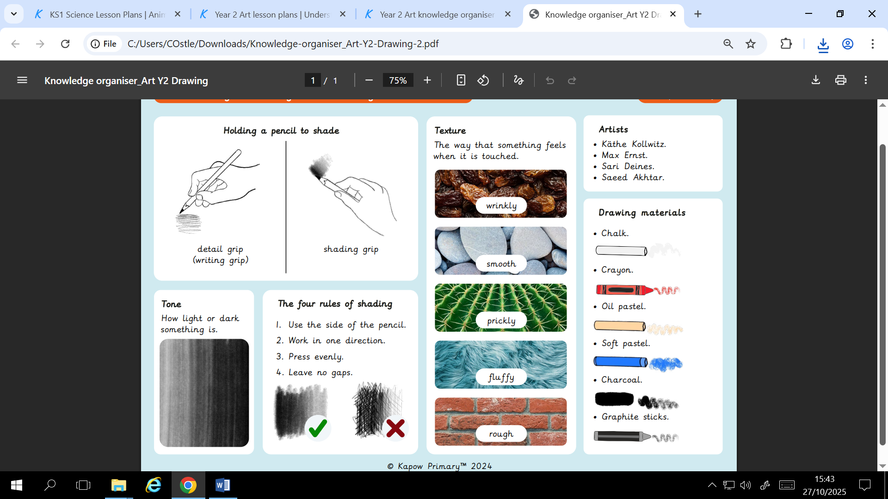
OBJECTIVES
Pupils who are secure will be able to:
- Experiment with a range of materials to create marks and tones.
- Use different pressures and control to make different marks.
- Describe the texture of objects.
- Identify how artists use tone.
- Control shading to show tone.
- Sketch simple shapes lightly so that changes can be made.
- Refine a drawing by building up the outline of an object.
- Pose to show a clear expression and head position to create a photograph.

 | FOCUS ARTIST INSPIRATION
Knowledge of artists
Applying their own understanding of art materials learnt from artist work to begin purposefully choosing materials for a specific effect.


