Richmond Hill Primary School – Geography 
Topic: At The Farm | Year: 2 | Strand: Human and Physical features
Vocabulary
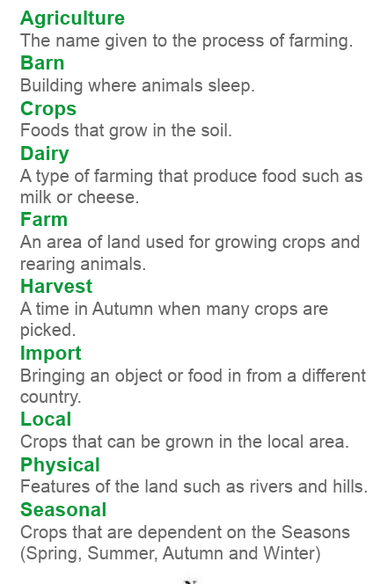
What should I already know?
- Our location is surrounded by lots of farms.
- Farms breed animals for dairy / meat or grow crops
- Countries of the UK
- ● Seasons and weather

What will I know by the end of the unit?
What farms are and why they are important? | - Arable farms grow crops like wheat.  - Livestock farms raise animals for meat, wool or eggs.  - Dairy farms produce milk to make cheese, yogurt or butter.
How the seasons affect life on a farm? | - Farms are busy places all year around but different things happen on farms during different seasons.
What are the features of a farm? | - Farms need lots of space so they are in the countryside, surrounded by fields.  - As well as open land for growing crops or keeping animals, lots of building are needed.
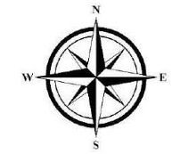
Diagrams
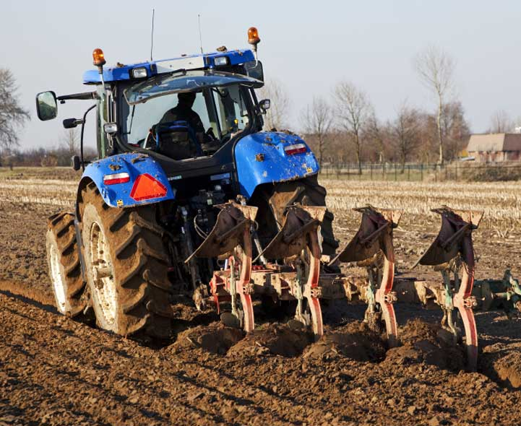 ploughing
milk – a dairy product 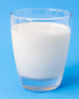
arable farming 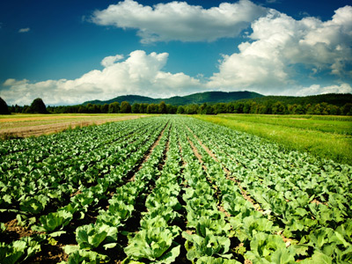

ploughing

Geographical Skills and Fieldwork
- Use basic geographical vocabulary to describe key physical features, including: forest, hill, sea, river, soil, season and weather. As well as key human features, including: town, village, farm and house.
● Identify seasonal and daily weather patterns in the United Kingdom.
● use simple compass directions (North, South, East and West).

milk – a dairy product
Arable farm

