Richmond Hill Primary School – Geography 
Topic: At The Farm | Year: 2 | Strand:
Vocabulary
arable | arable is where farmers plough the land, sow seeds and grow plants to harvest
autumn | the season after summer and before winter
calf | a baby cow
countryside | rural areas are quieter places which are not towns or cities
dairy | dairy farms use milk from cows, goats and other animals to create products like cheese, yogurt and butter
livestock | a farm that focuses on raising animals instead of crops
orchard | where trees or shrubs that produce food are grown
pasture | an area of land for grazing
ploughing | a farm implement consisting of a strong blade at the end of a beam
rural | the characteristic of the countryside rather than town or city
season | they are four seasons in a year
spring | the weather usually turns warmer, trees begin to grow their leaves, plants start to flower and young animals such as chicks and lambs are born in this season
summer | the season between spring and autumn which in the northern hemisphere, is usually the months of June, July, and August
urban | urban habitats are found in towns and cities
winter | the season after autumn and before spring

What should I already know?
- Our location is surrounded by lots of farms.
- Farms breed animals for dairy / meat or grow crops
- What seasons are and how they change.

What will I know by the end of the unit?
What farms are and why they are important? | - Arable farms grow crops like wheat.  - Livestock farms raise animals for meat, wool or eggs.  - Dairy farms produce milk to make cheese, yogurt or butter.
How the seasons affect life on a farm? | - Farms are busy places all year around but different things happen on farms during different seasons.
What are the features of a farm? | - Farms need lots of space so they are in the countryside, surrounded by fields.  - As well as open land for growing crops or keeping animals, lots of building are needed.
Diagrams
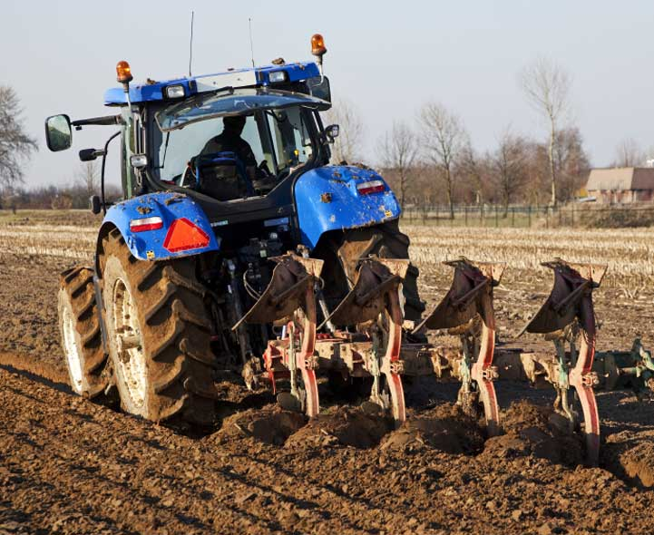 ploughing
milk – a dairy product 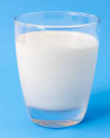

arable farming 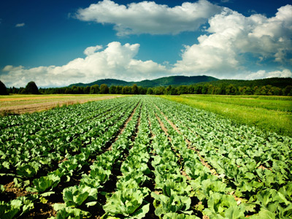

ploughing

milk – a dairy product
Geographical Skills and Fieldwork
- Why are farms important?
- Can you name some of the features of a farm?
- Can you name all four seasons? Can you describe what happens on a farm during each of the seasons?
- Can you identify ways in which towns and
farms are different?

Arable farm

